**“ AWS Solutions Architecture Job Simulation ”**

**January-2024**

**Given Architecture**

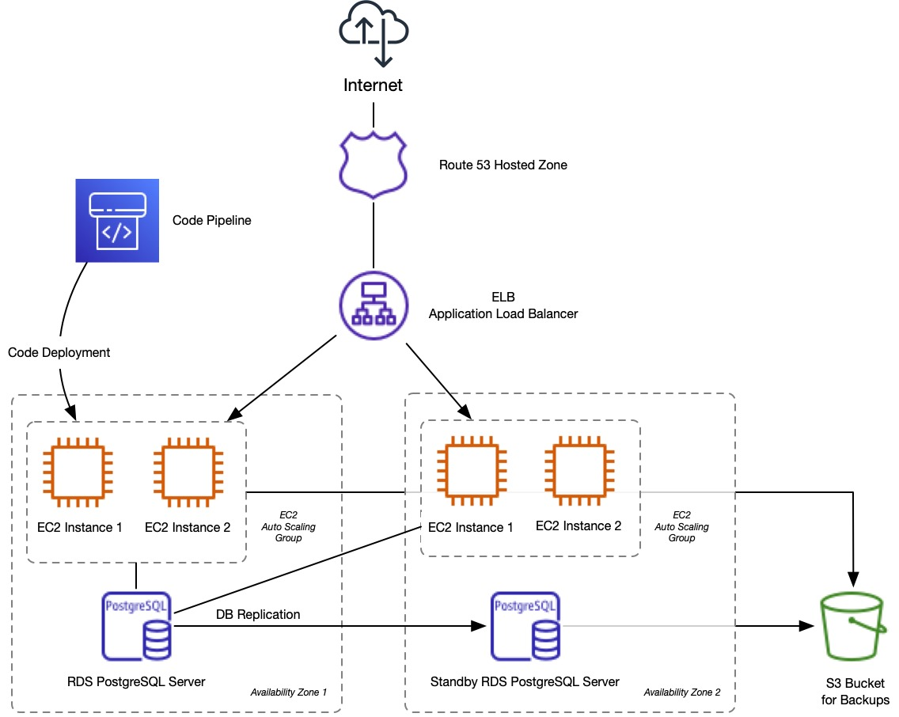

**Partial Implementation of Architecture**

Create VPC:

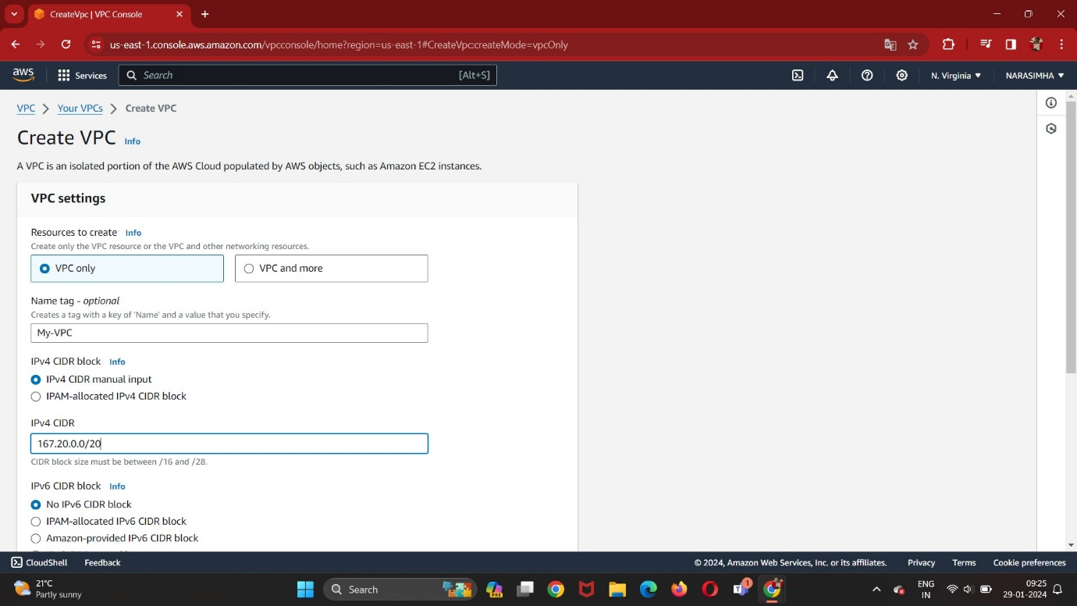

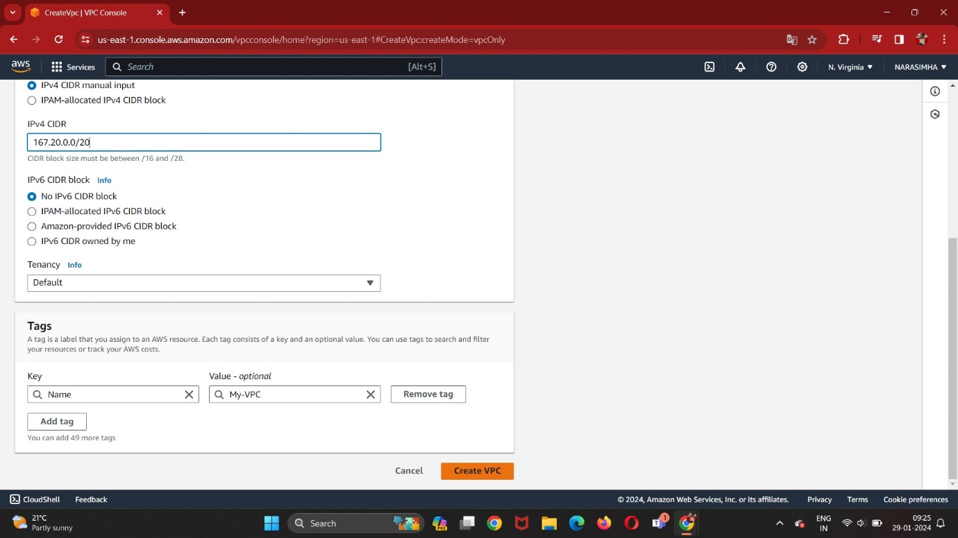

Creating Subnets:

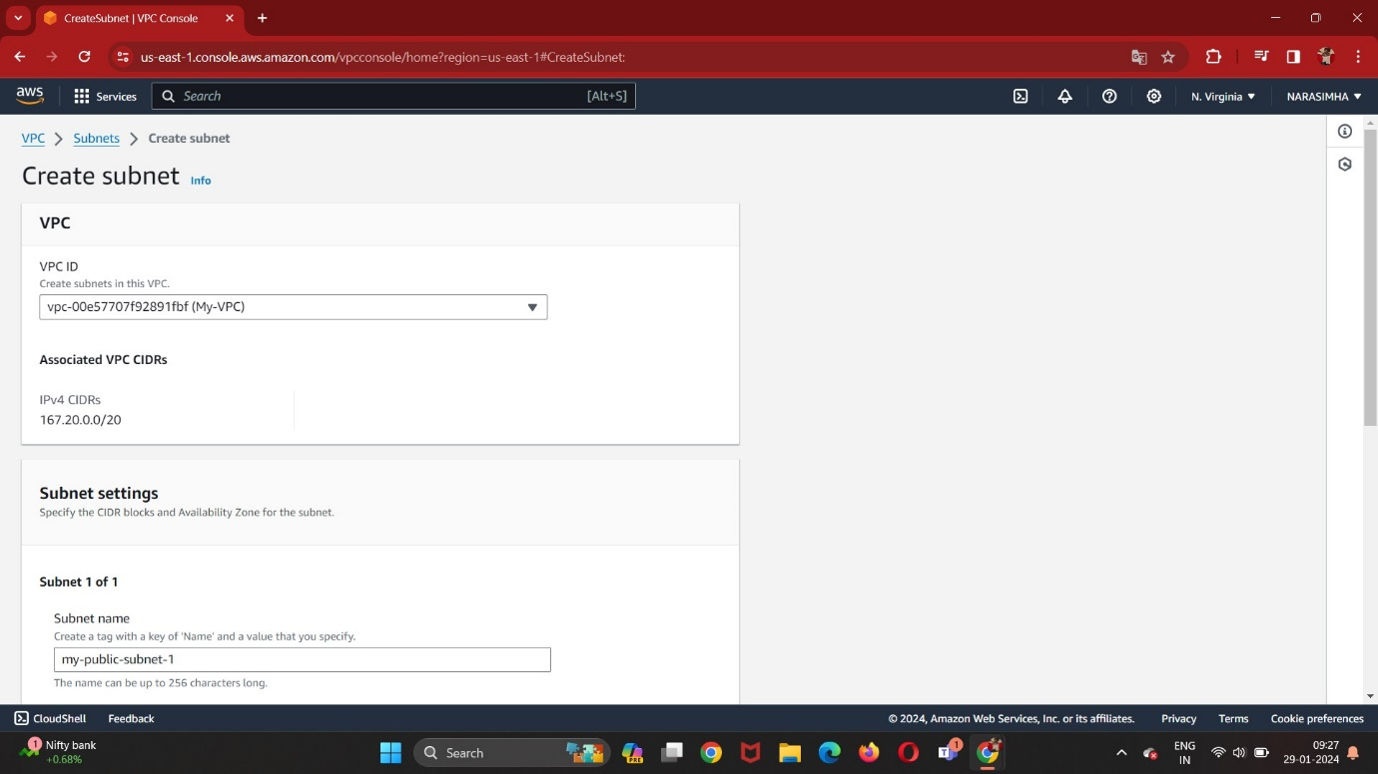

my-puclic-web-subnet-1

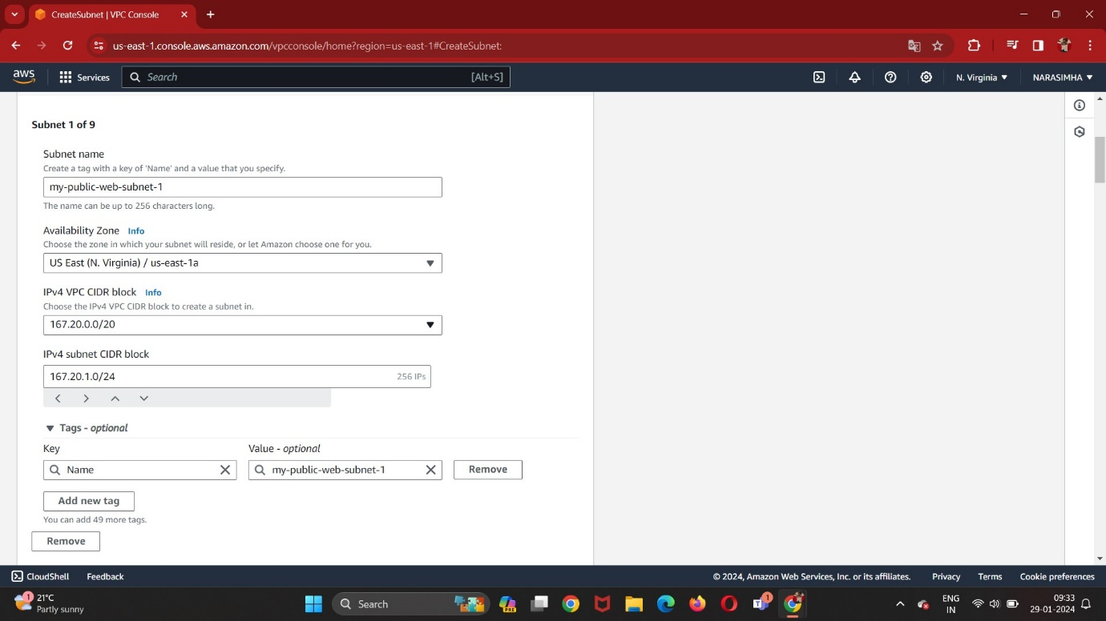

my-puclic-web-subnet-2

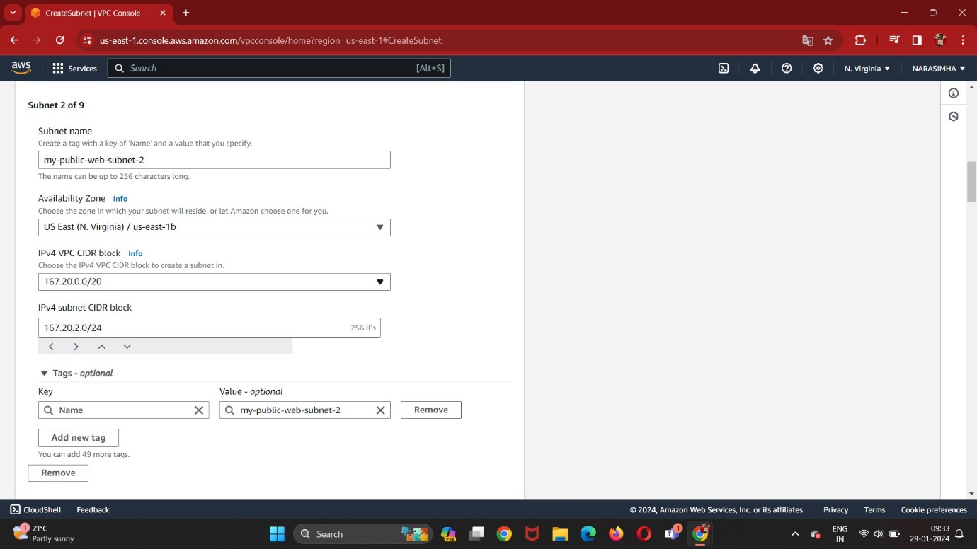

my-puclic-web-subnet-3

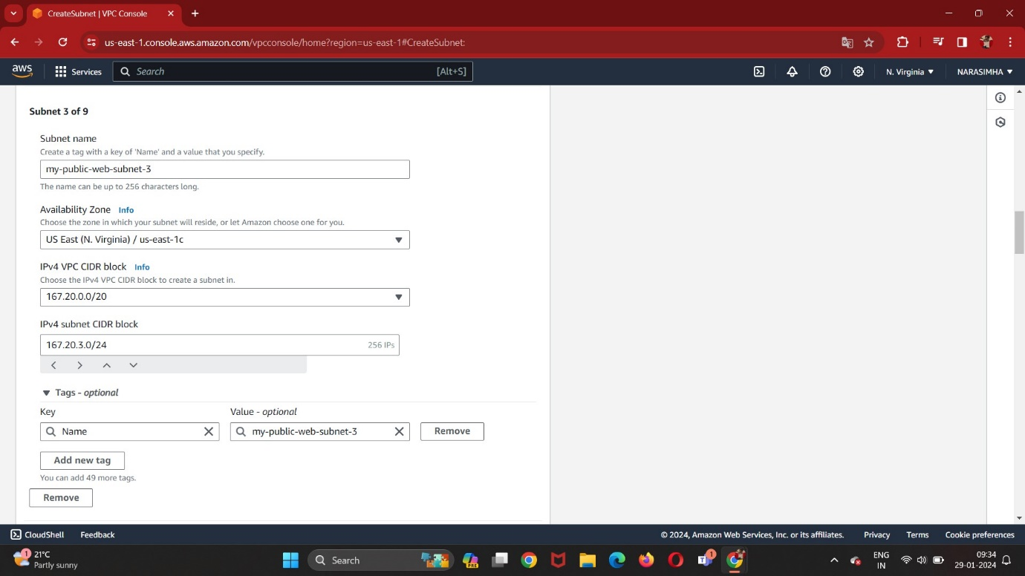

my-private-app-subnet-1

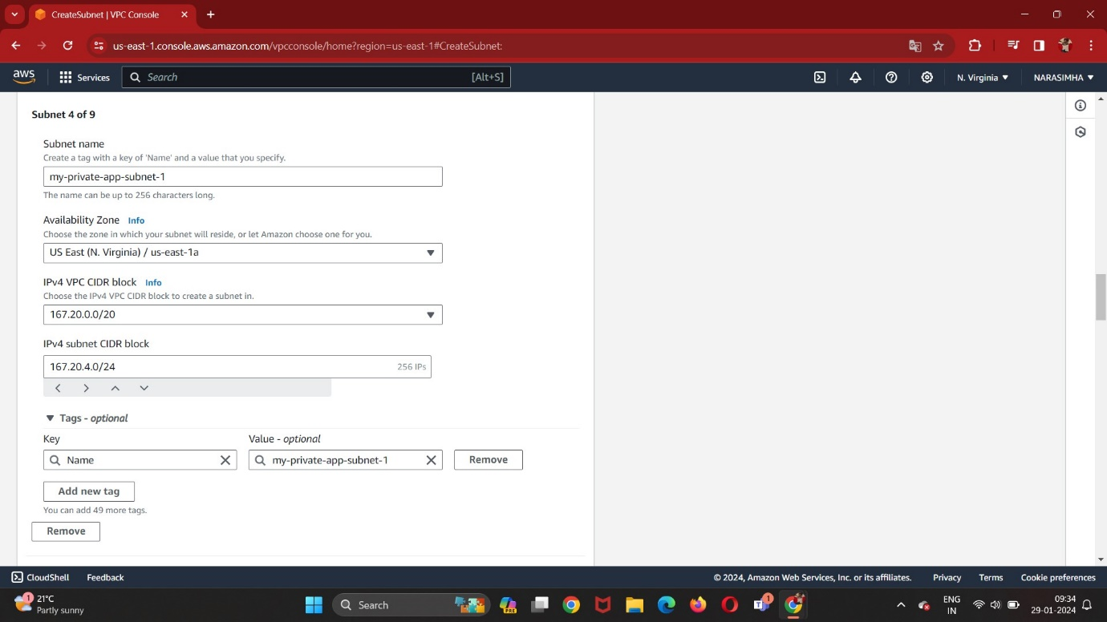

my-private-app-subnet-2

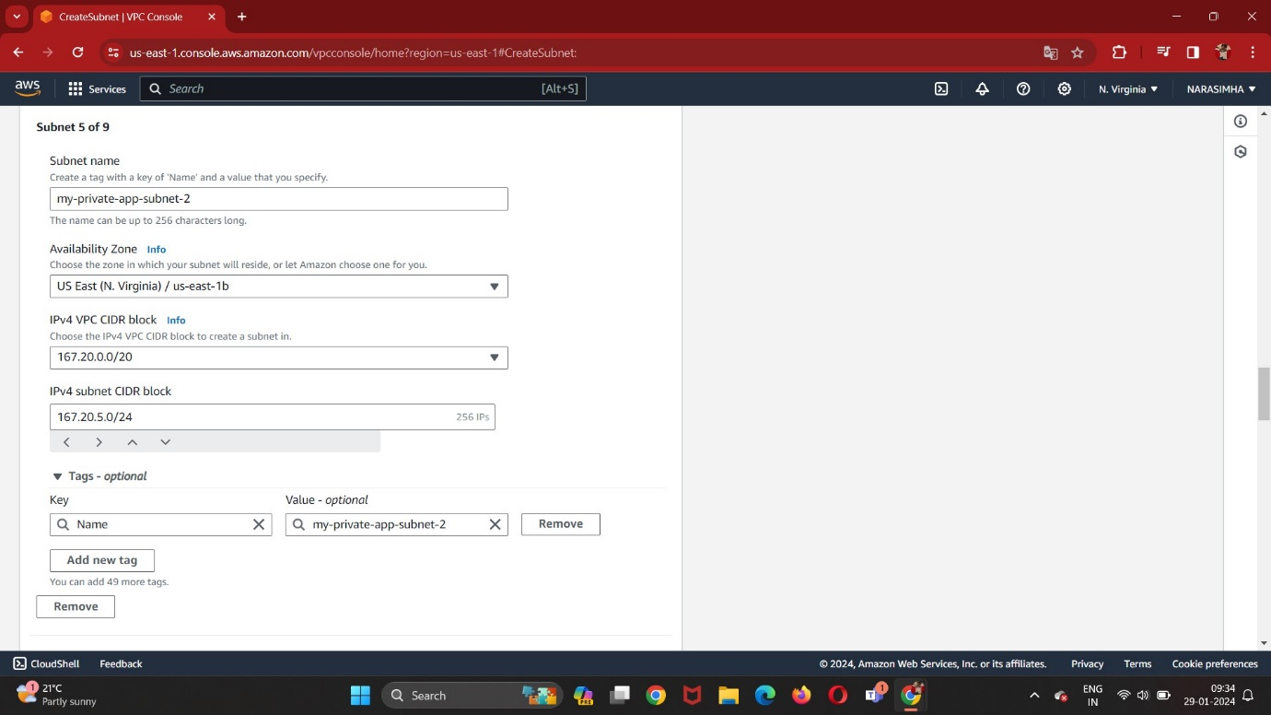

my-private-app-subnet-3

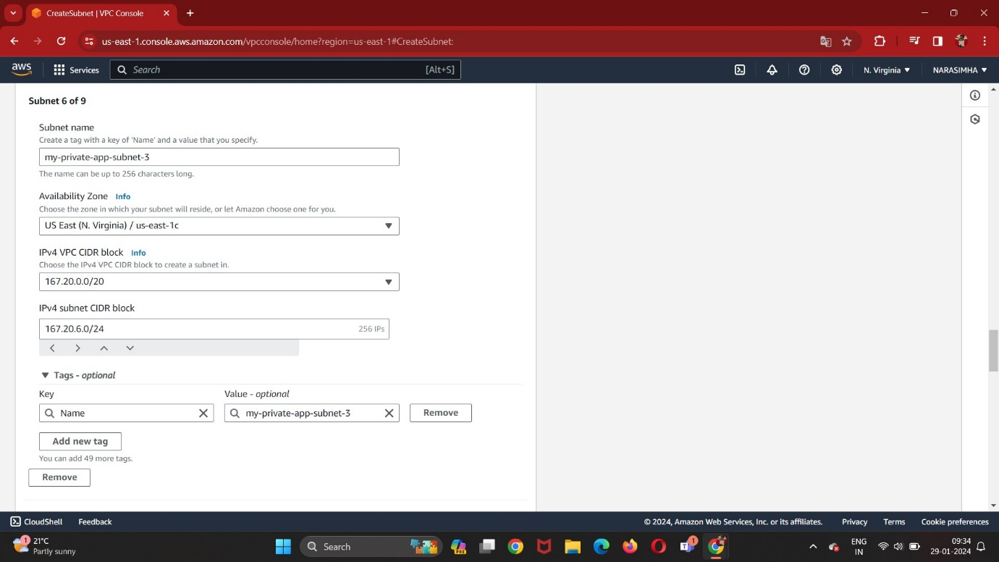

my-private-db-subnet-1

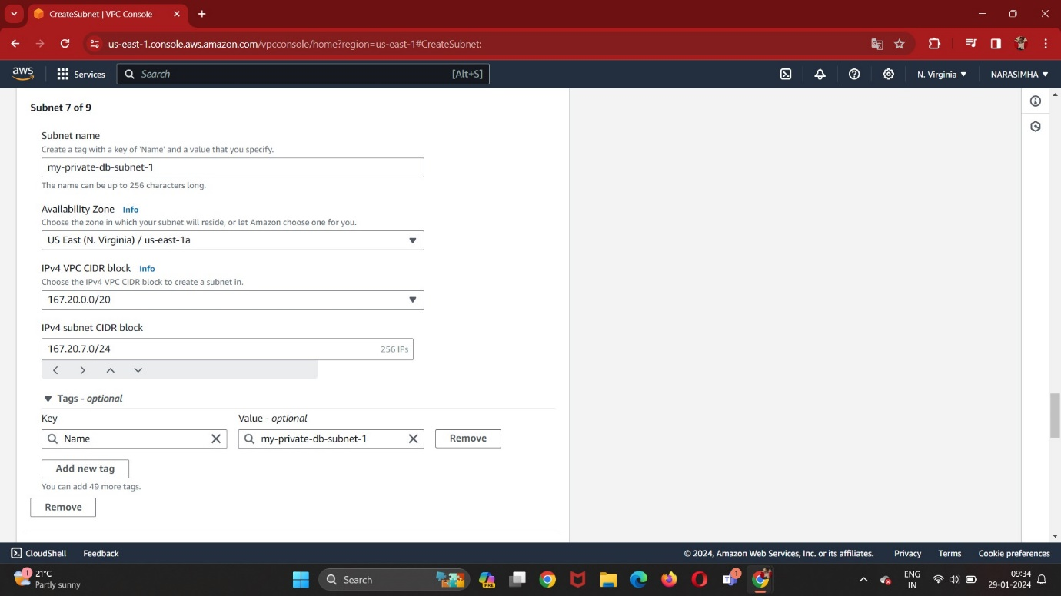

my-private-db-subnet-2

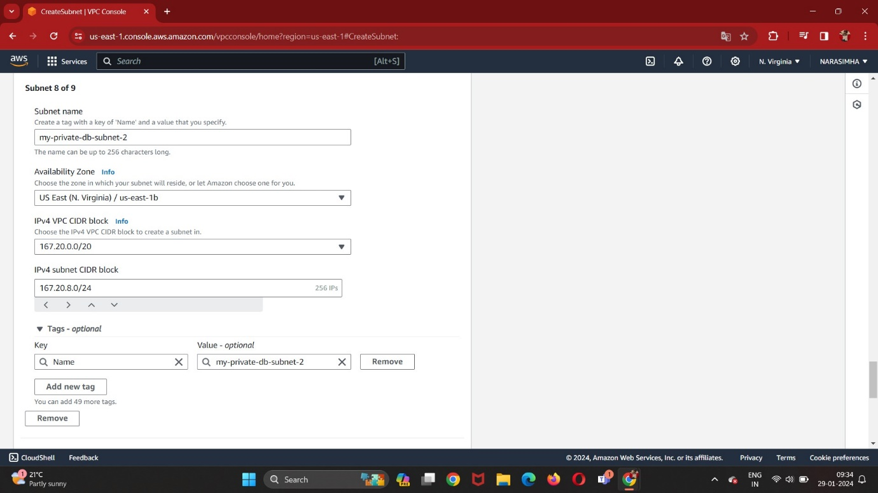

my-private-db-subnet-3

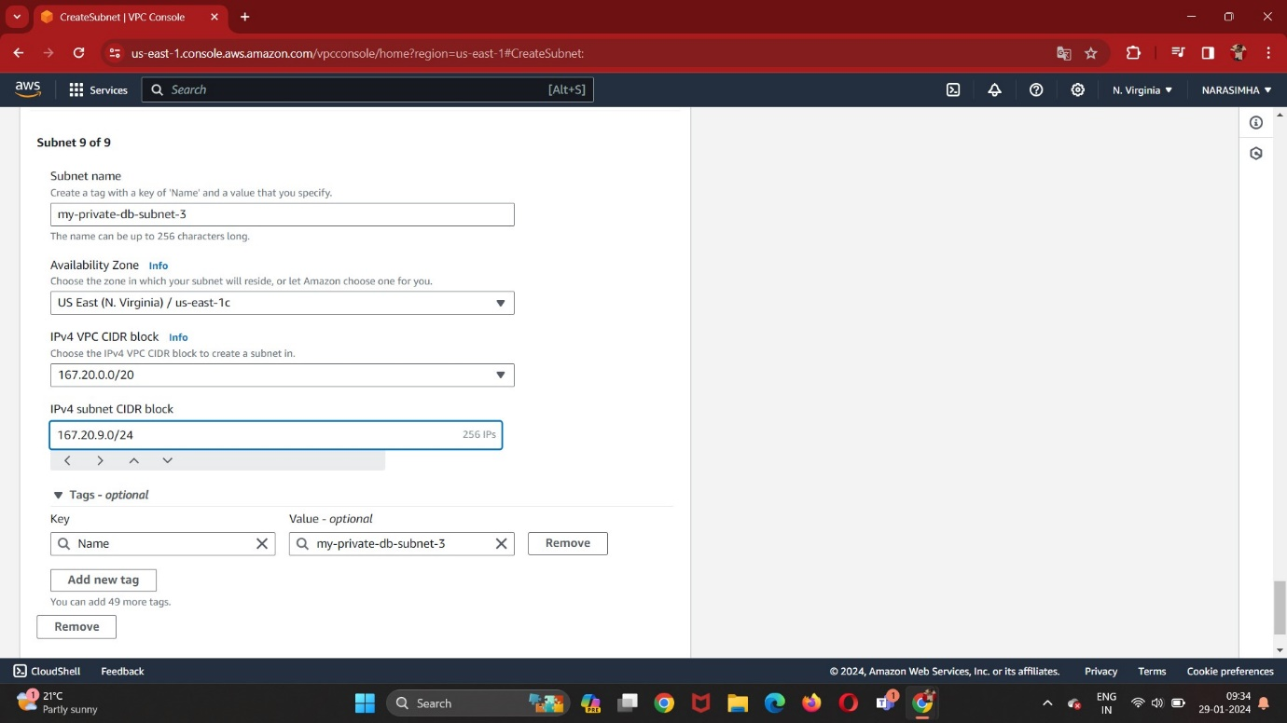

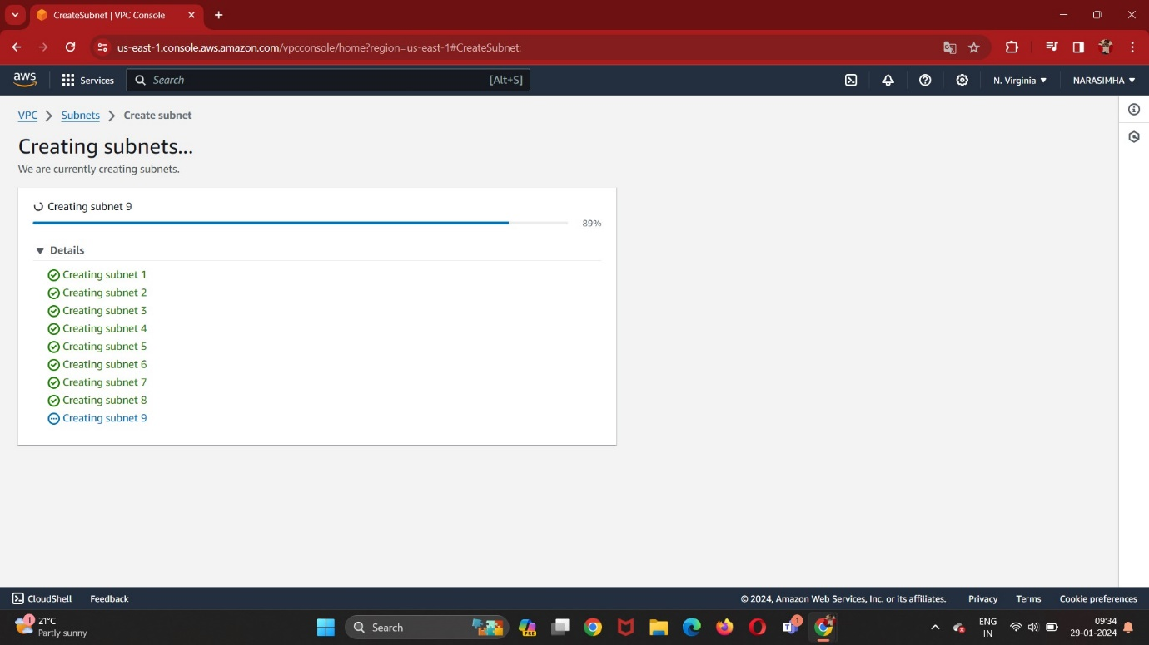

my-public-web-route-table

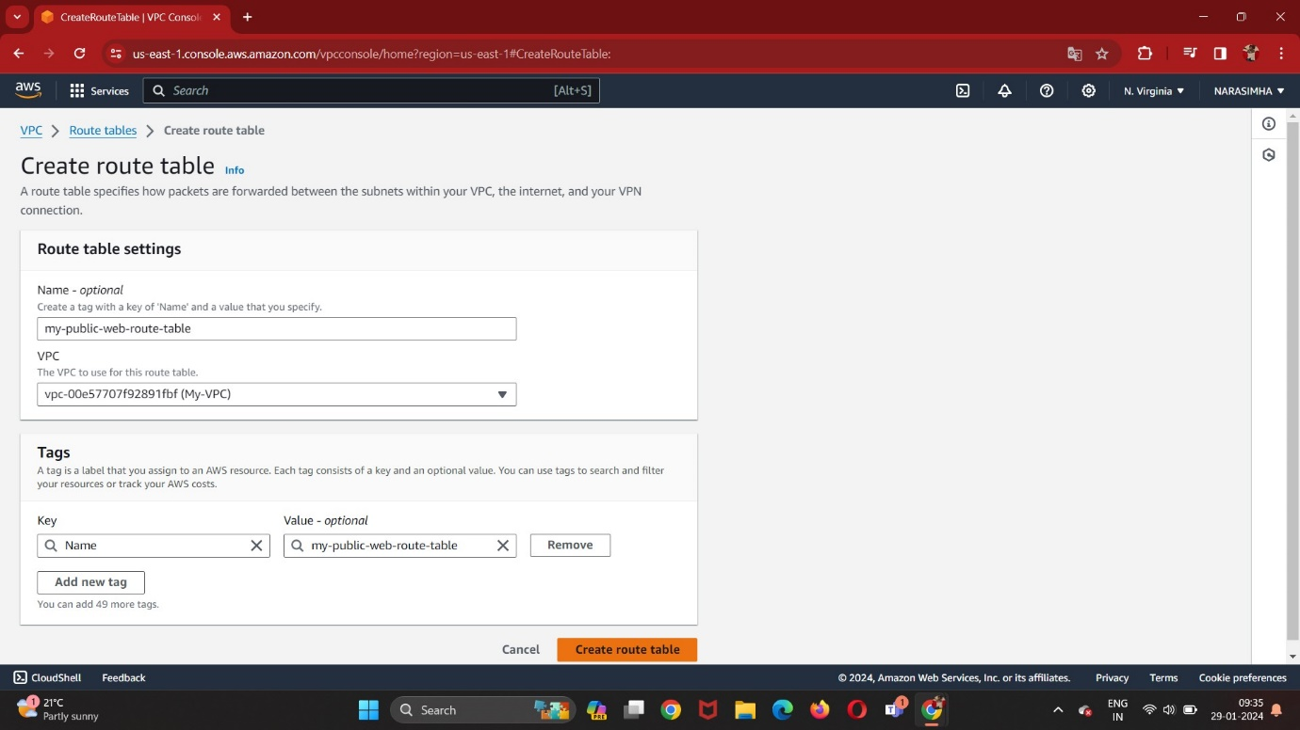

my-private-app-route-table

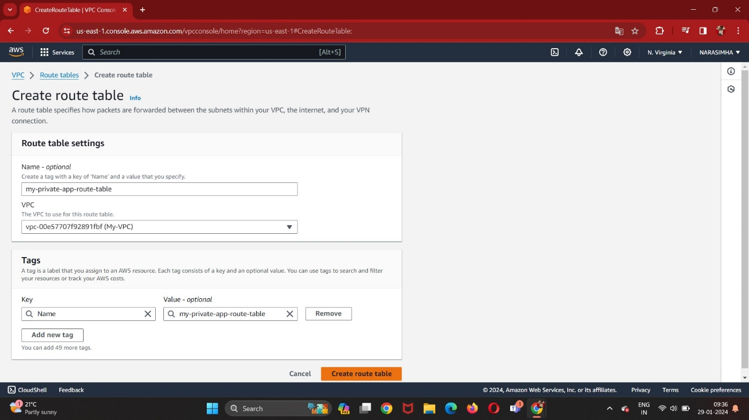

my-private-db-route-table

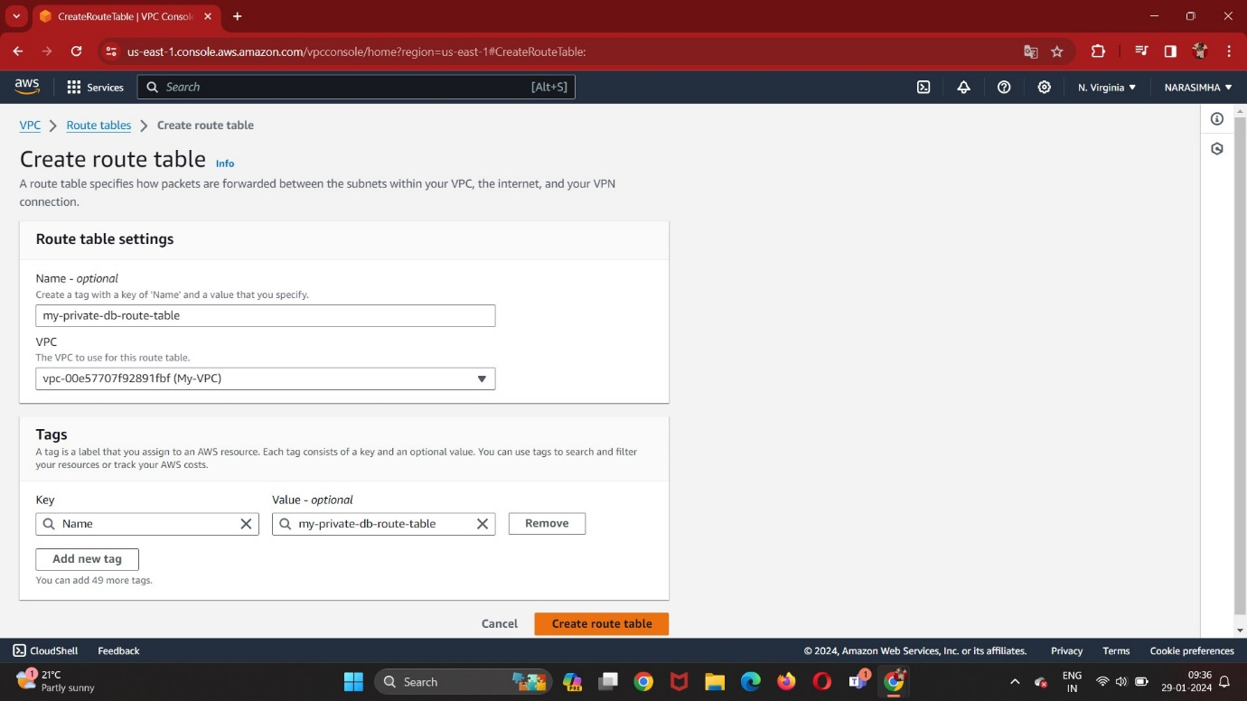

Subnet Association:

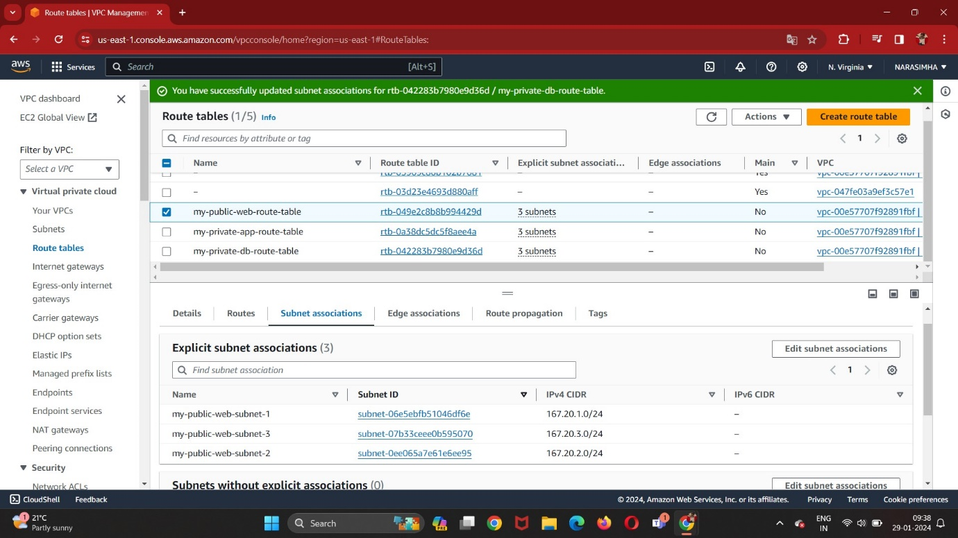

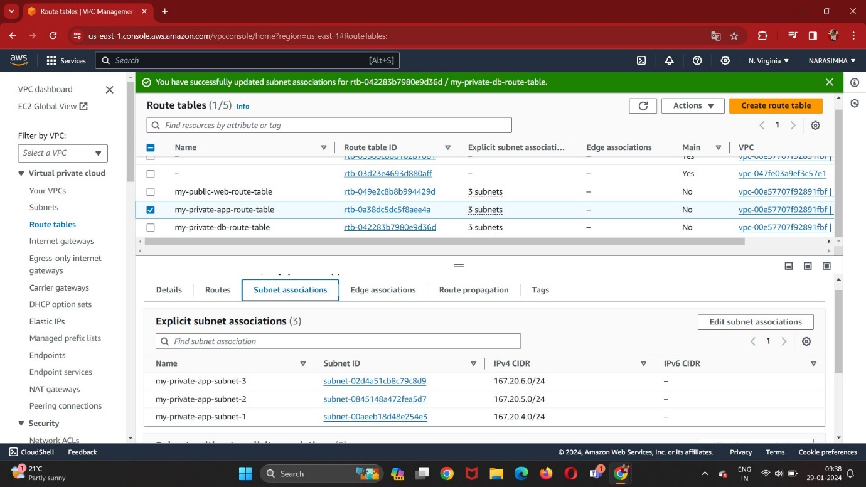

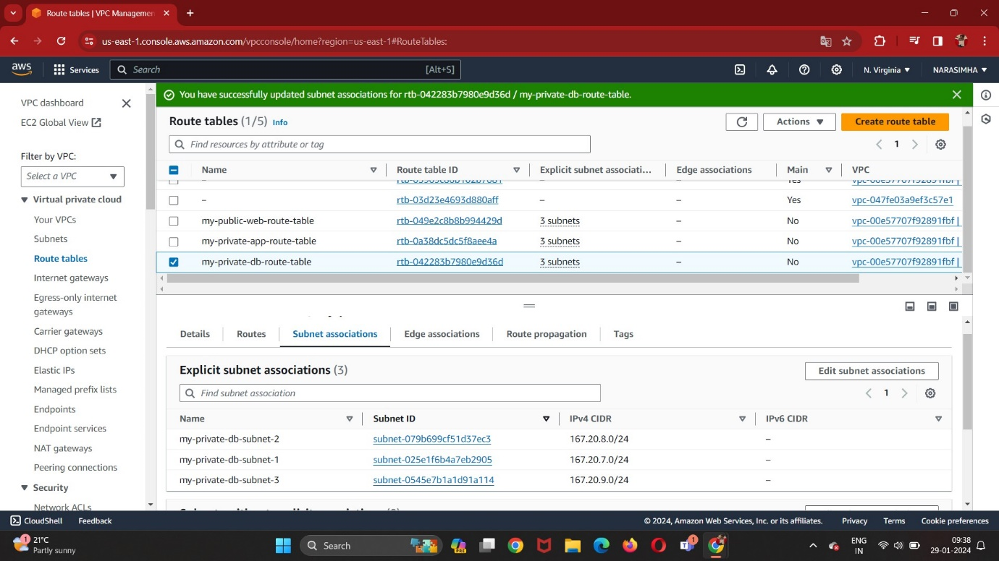

Create Internet Gateway:

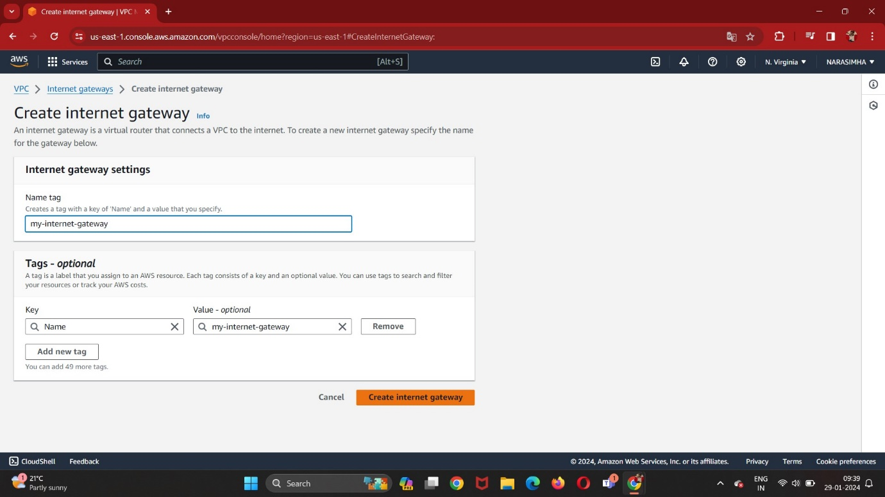

Attach to the VPC:

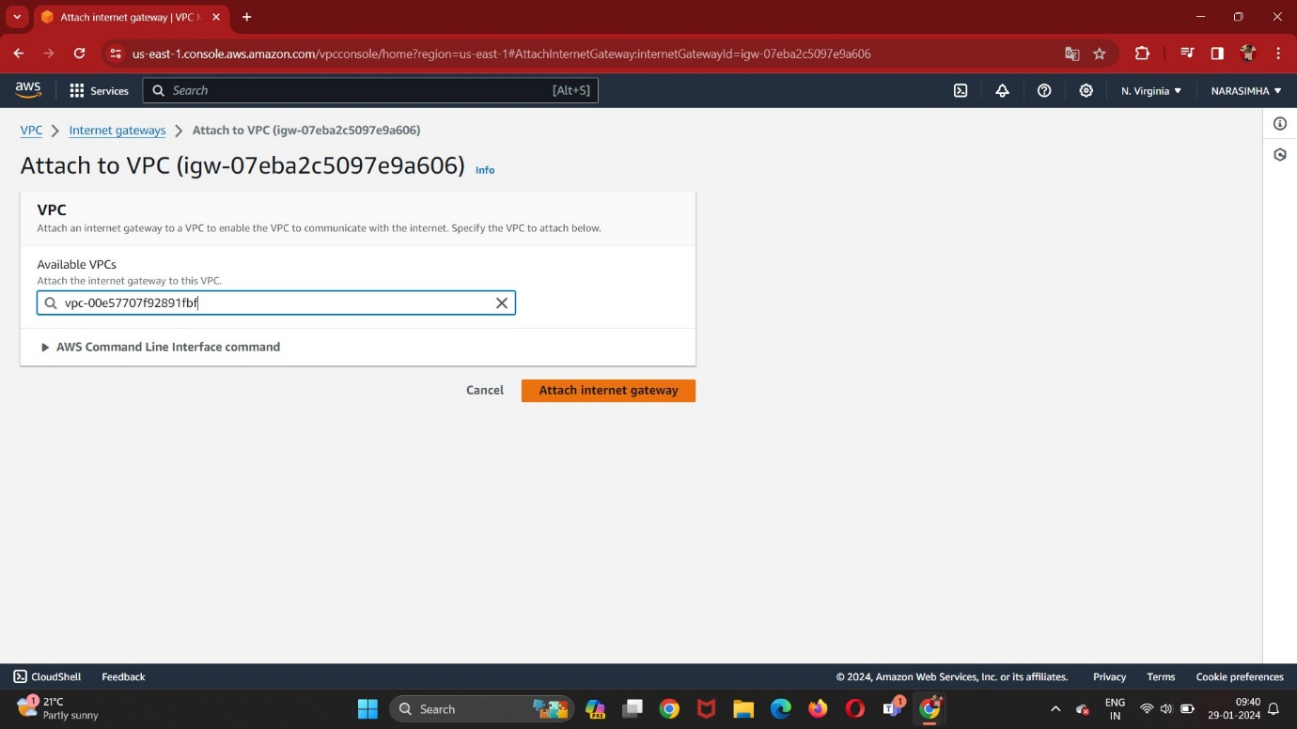

Create NAT Gateway:

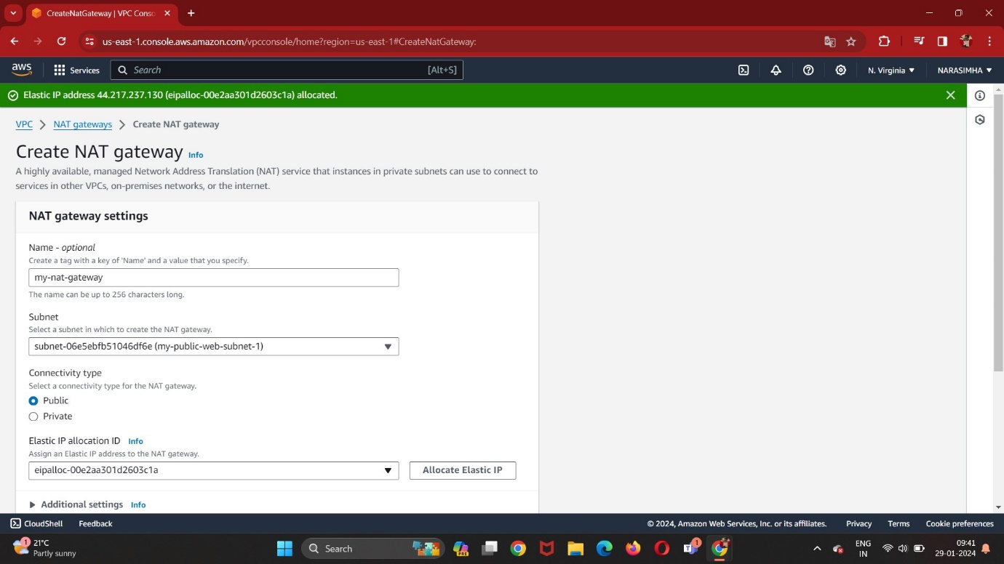

Edit Routes:

Public-Web Route Table

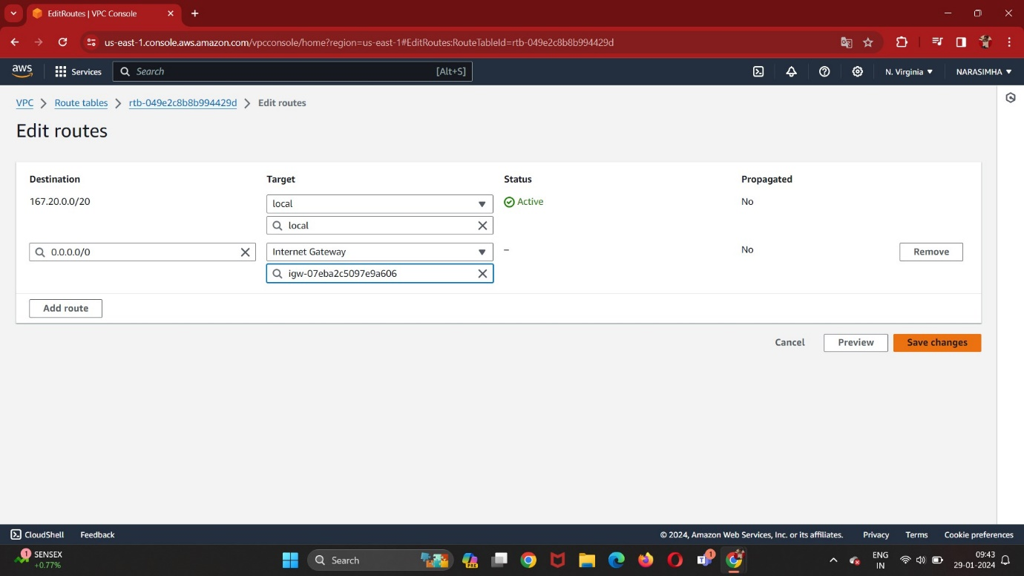

Private-App Route Table:

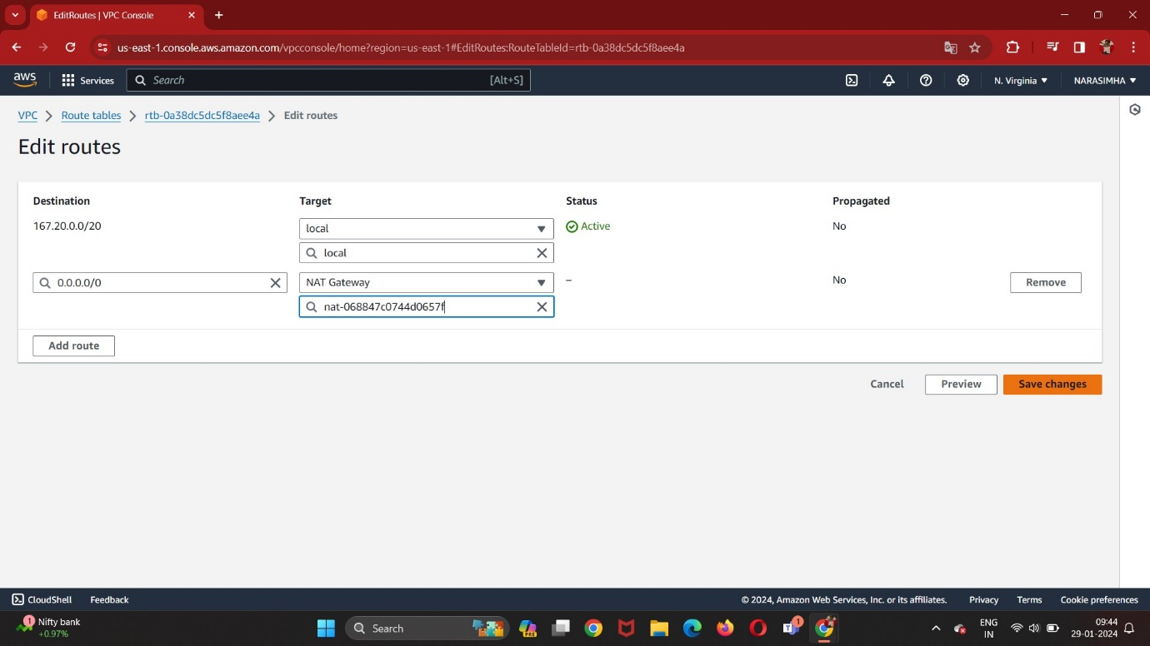

Private-DB Route Table:

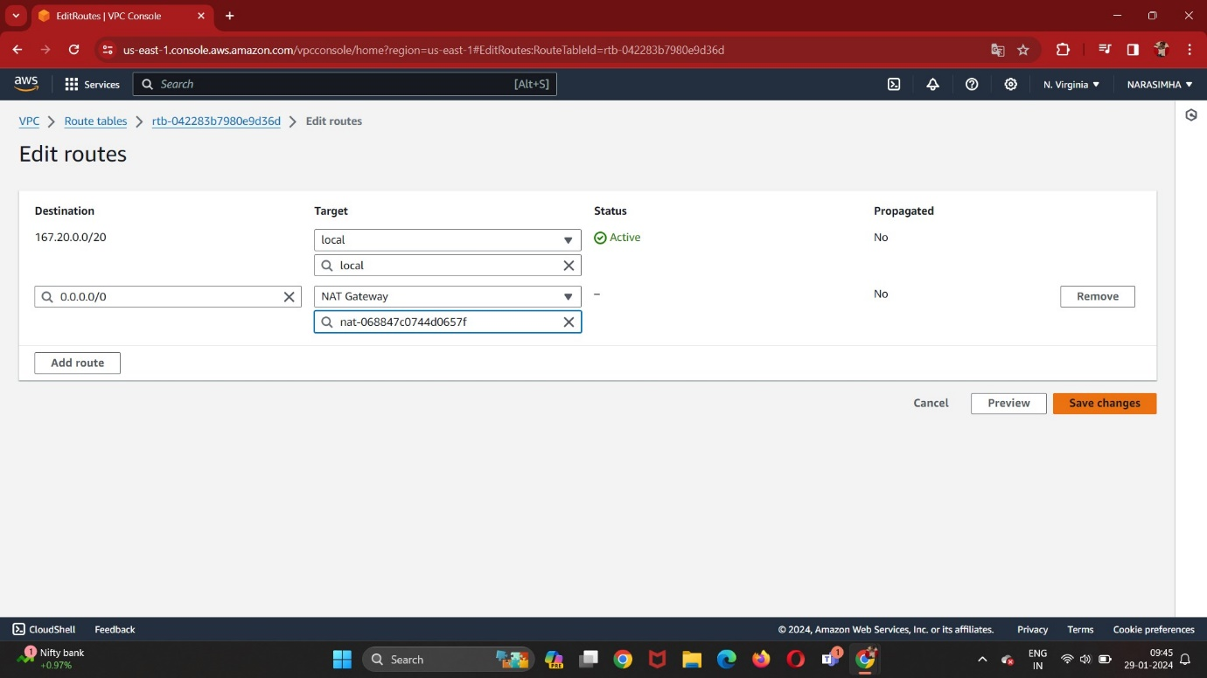

Create Jump Server:

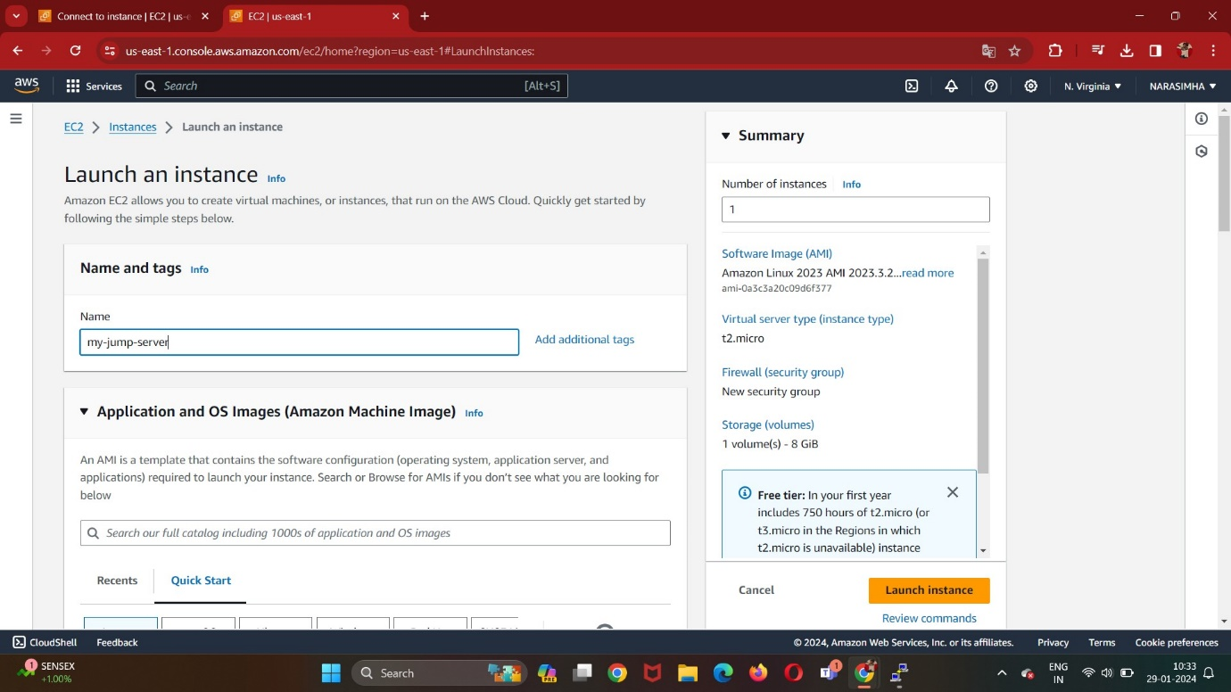

Amazon Linux 2 AMI:

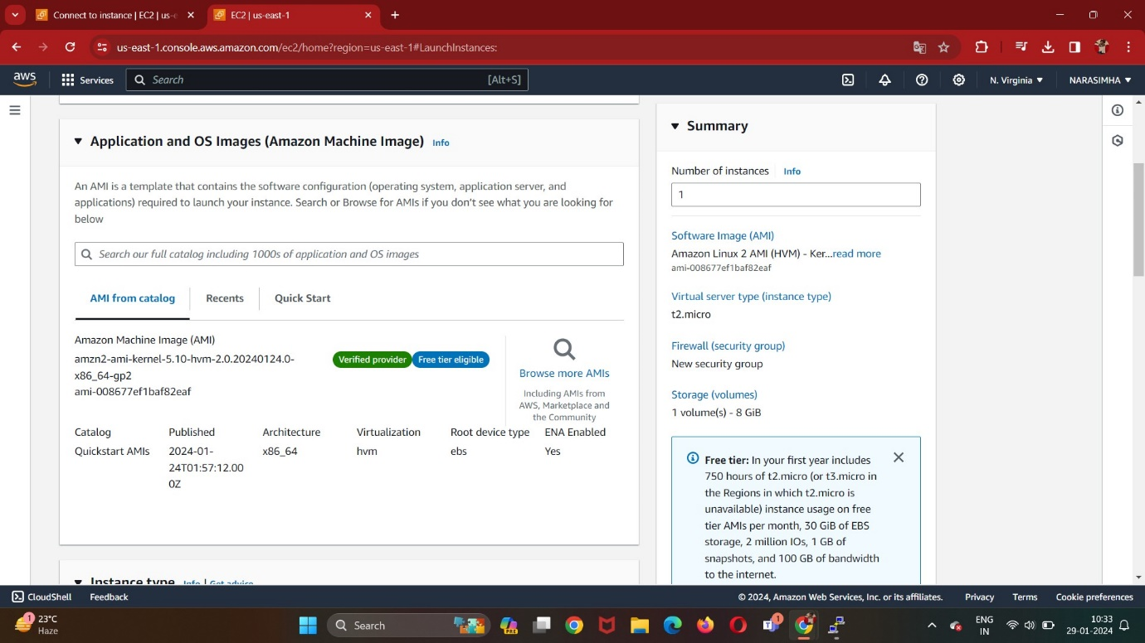

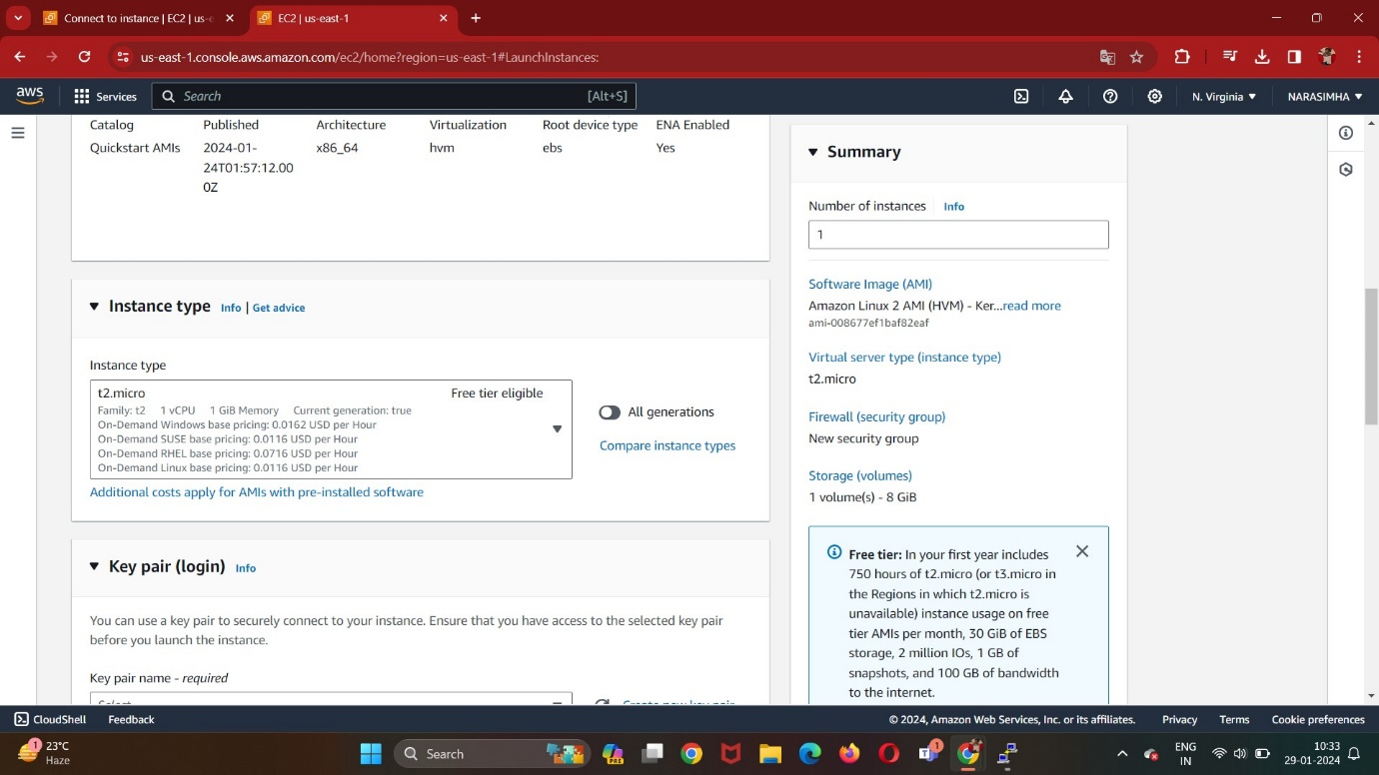

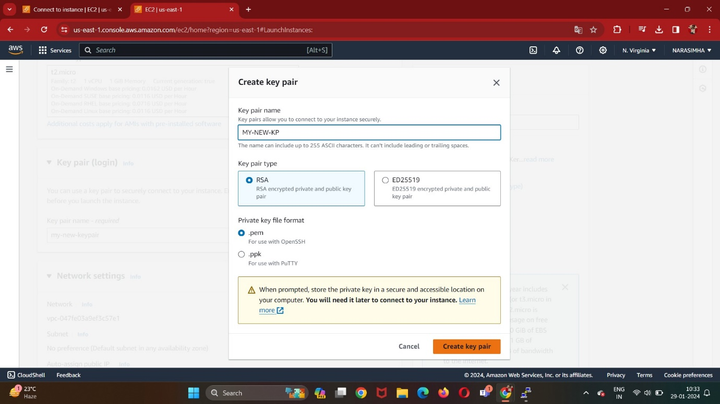

Enable auto assign IP:

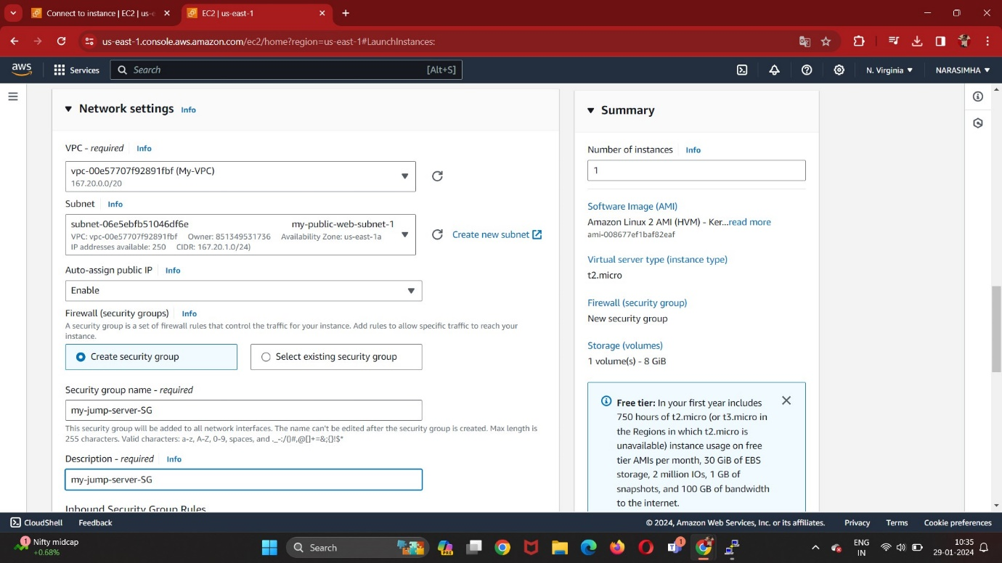

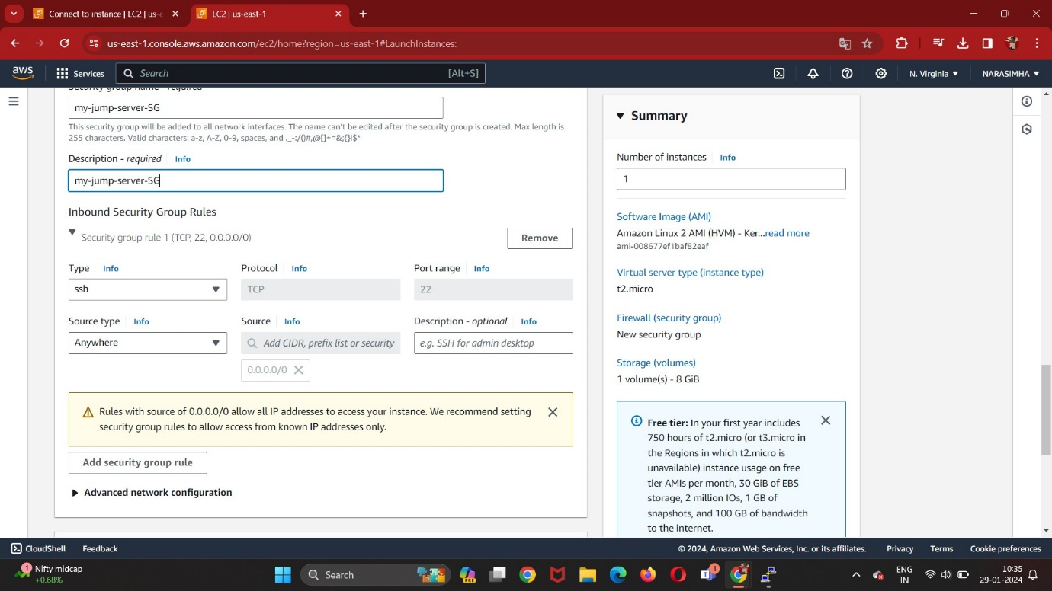

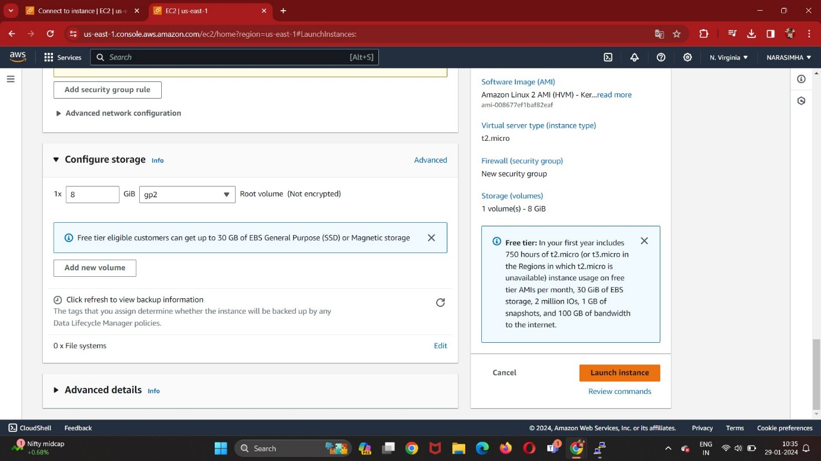

Creating PHP Instance-1:

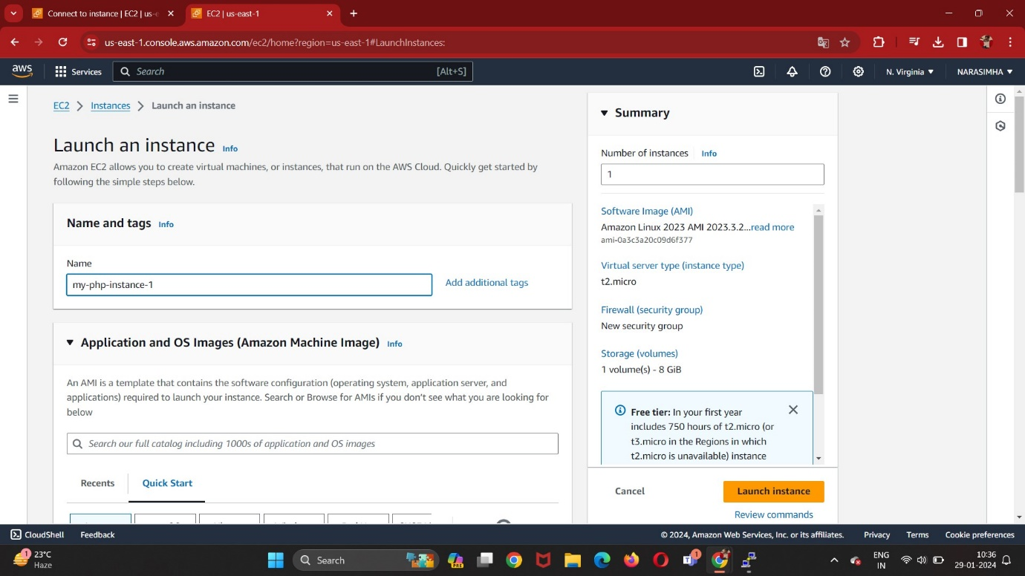

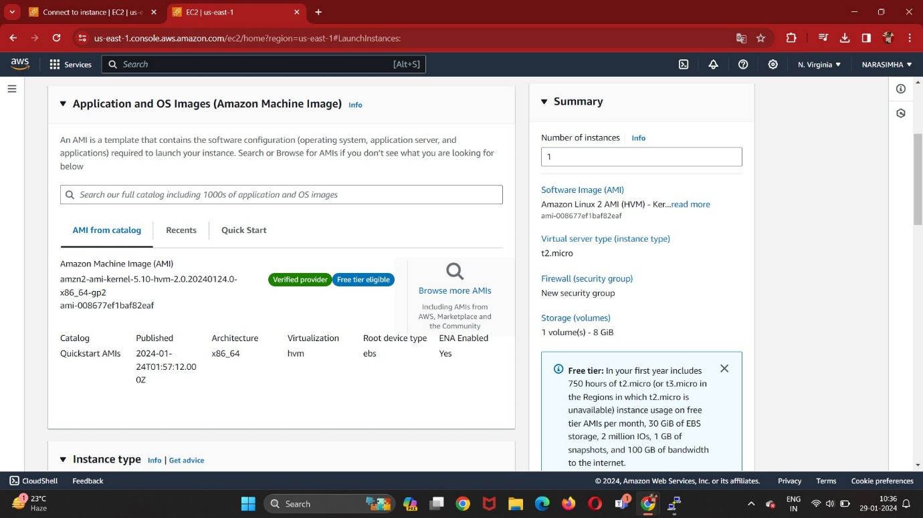

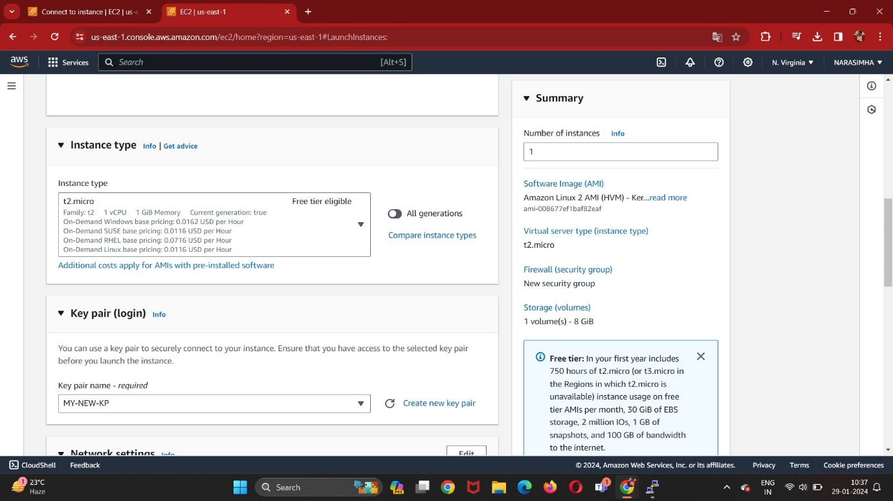

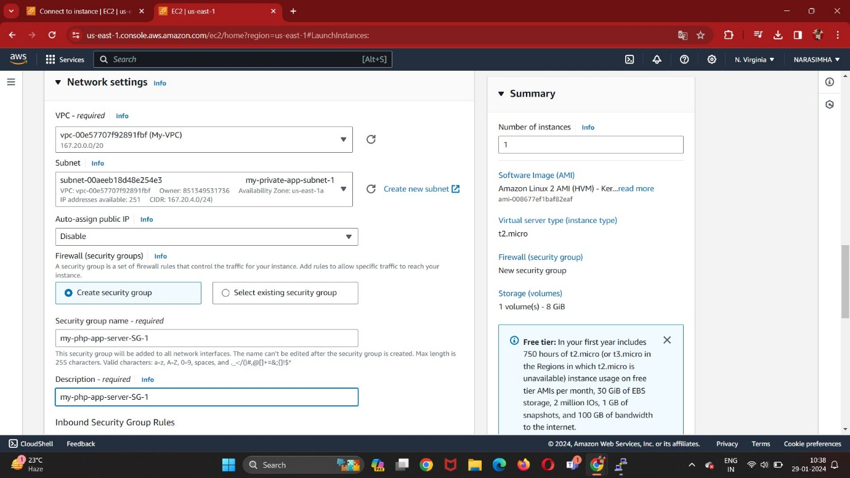

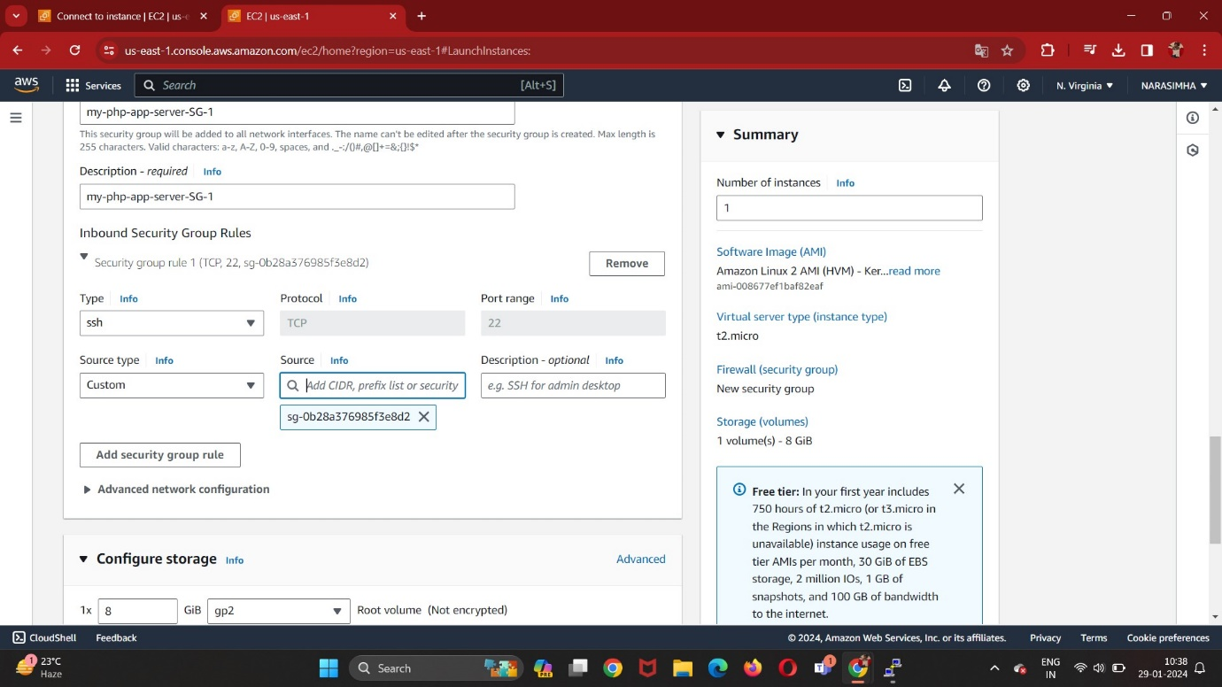

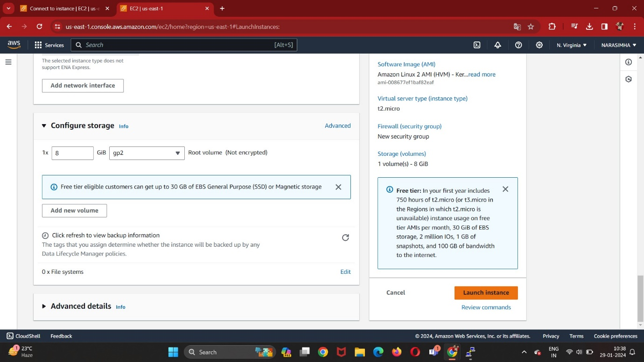

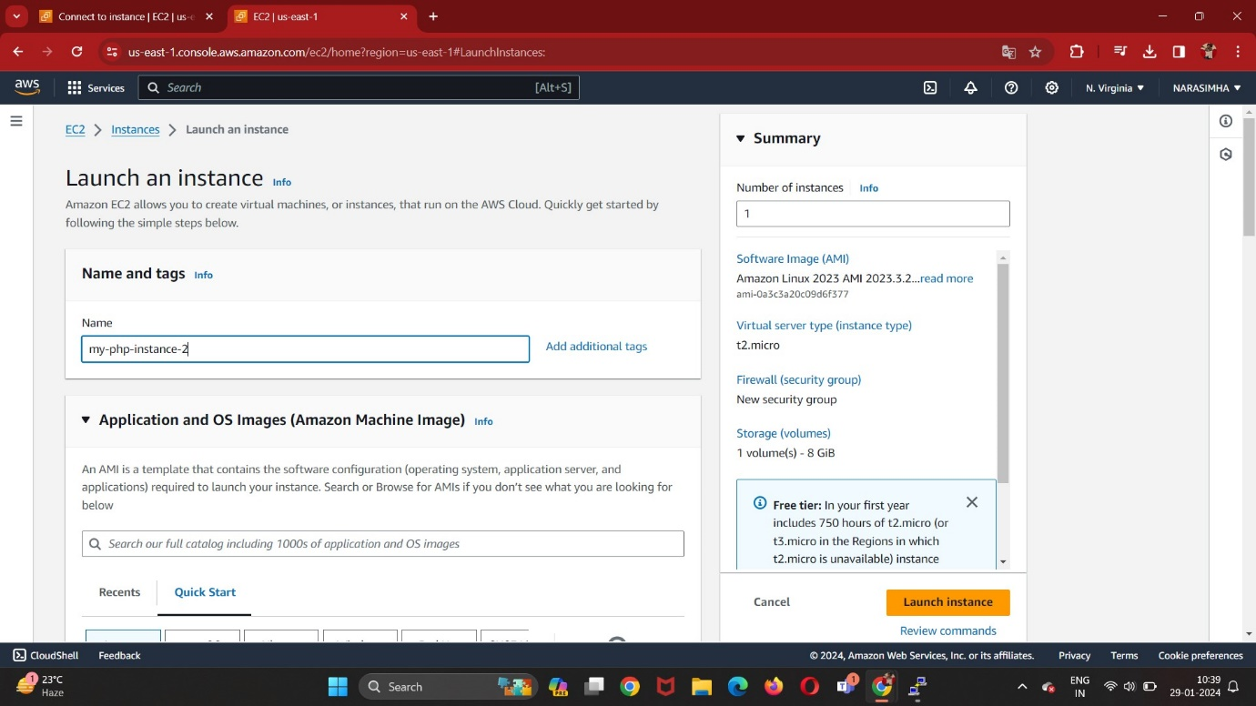

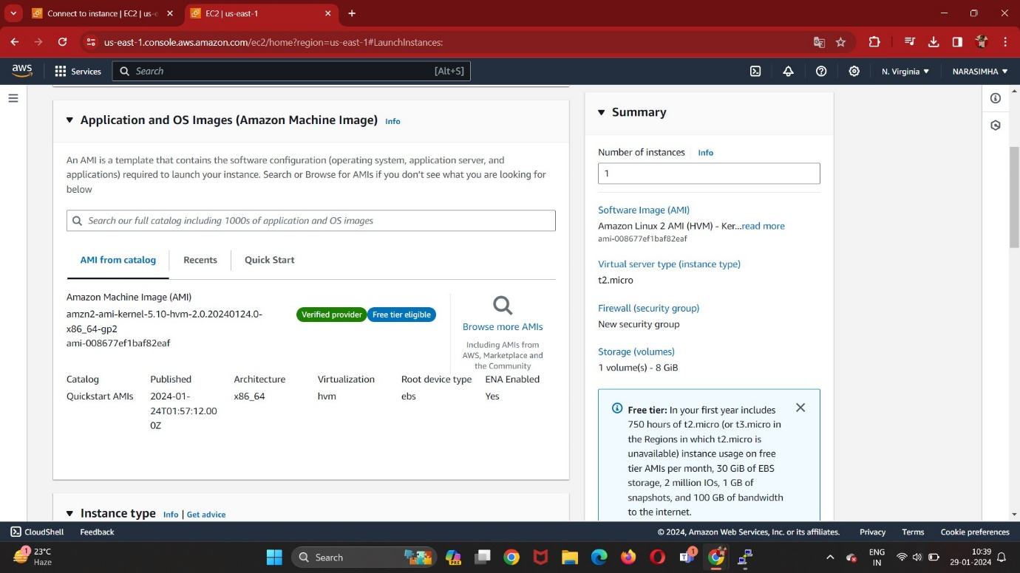

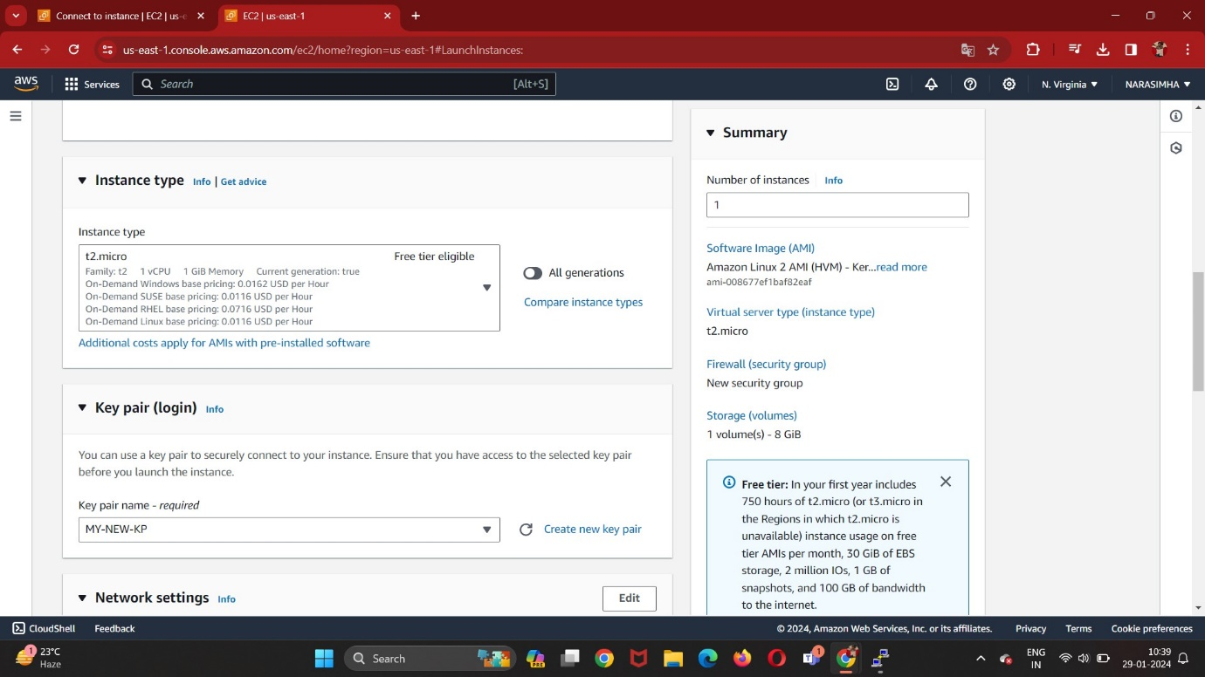

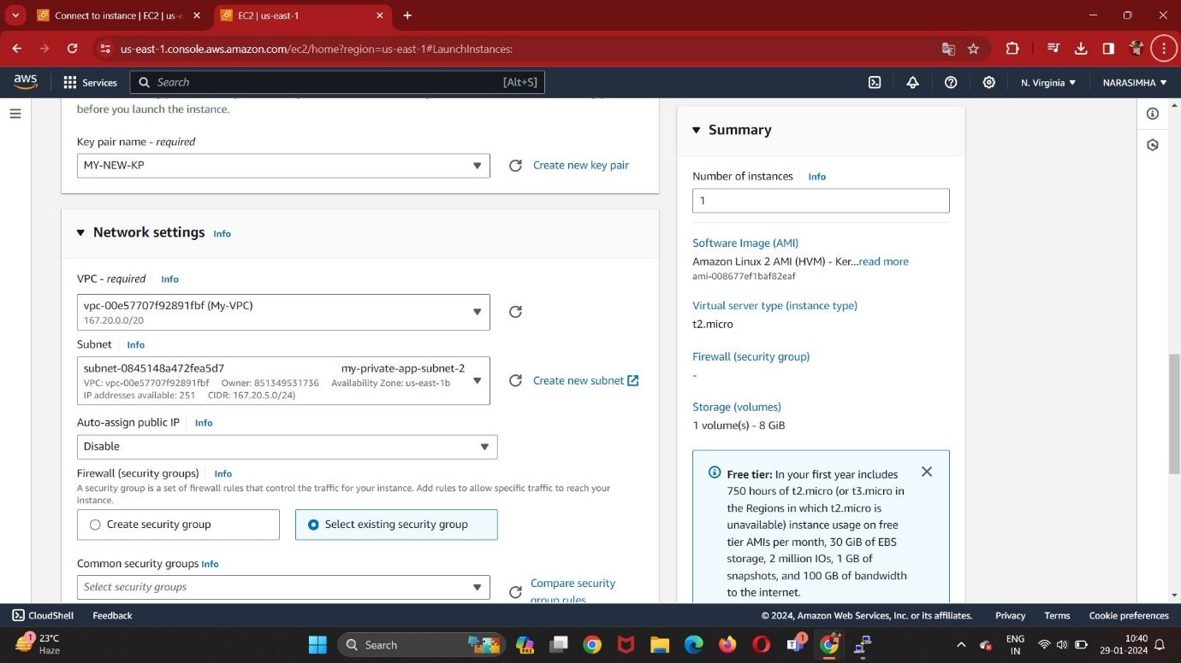

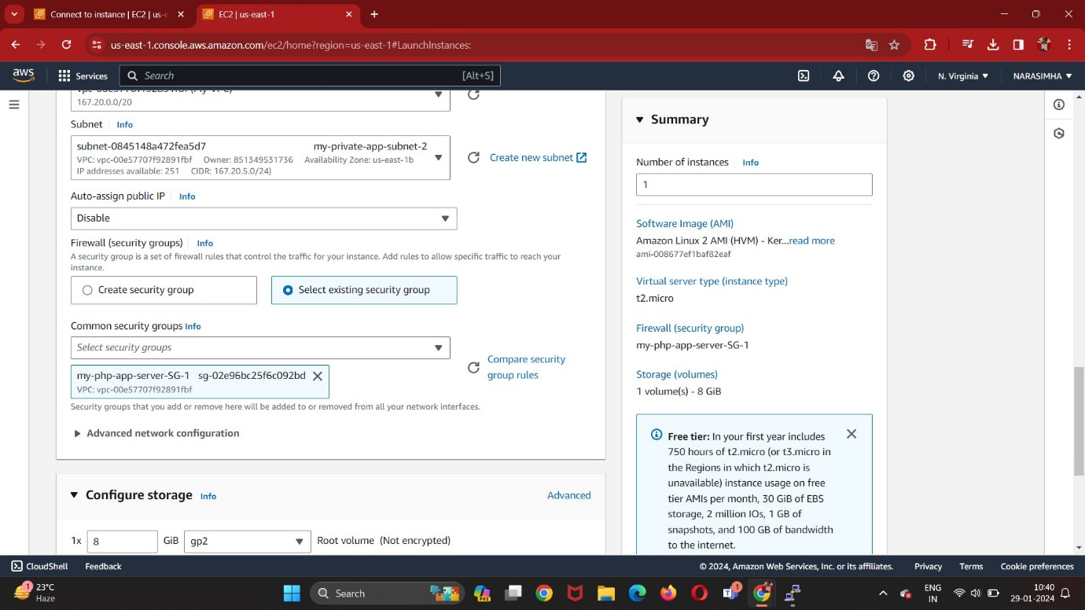

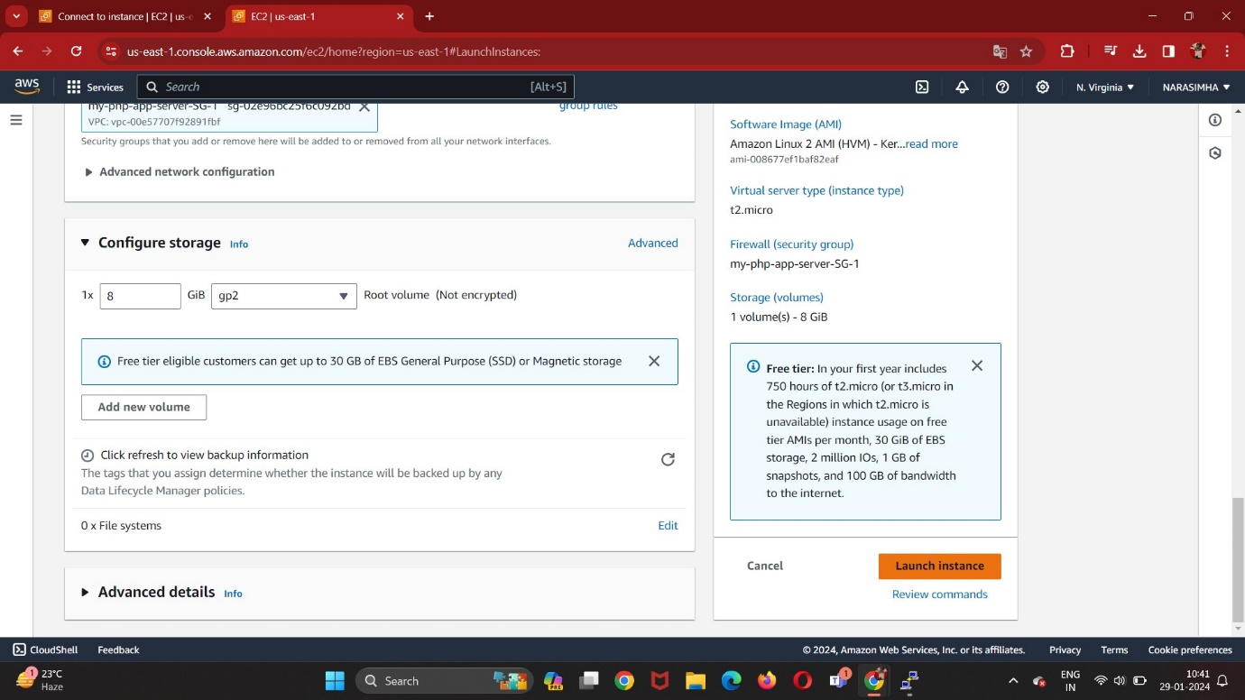

Login to the Jump Server using Command Prompt using command:  
“ ssh-i ‘MY-NEW-KP.pem’ ec2-user@52.55.229.217 ”

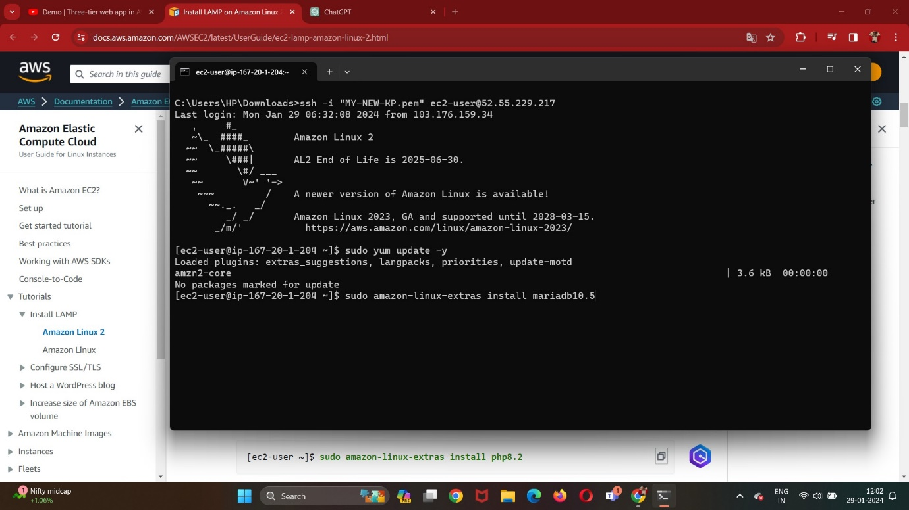

Now go to php-app instance-1 using command:

“ ssh-i ‘MY-NEW-KP.pem’ ec2-user@167.20.4.241 ”:

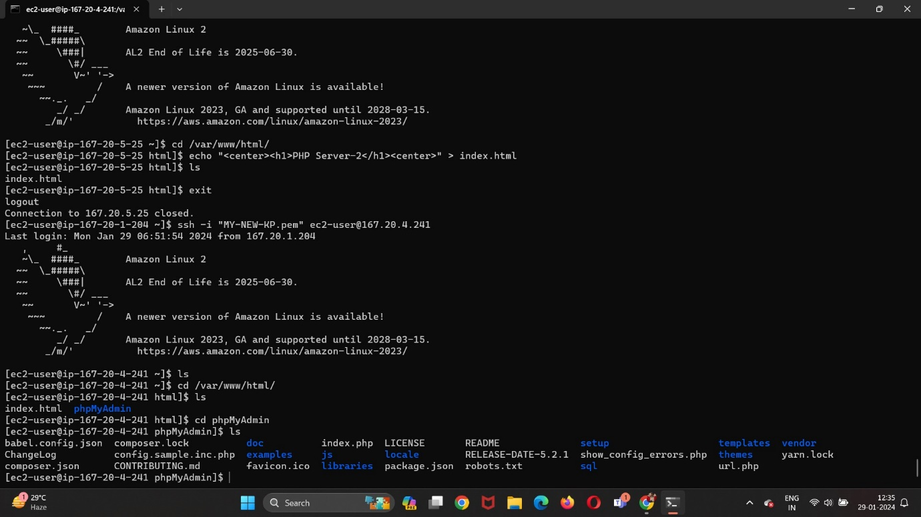

And Execute all the commands in below command set.

Goto /var/www/html/ Directory and execute echo “PHP-Server-1” > index.html

Now go to php-app instance-2 using similar ssh-i command for php-app instance-2:

And Execute all the commands in below command set.

Goto /var/www/html/ Directory and execute echo “PHP-Server-1” > index.html

Command Set:

sudo yum update -y

sudo amazon-linux-extras install mariadb10.5

sudo amazon-linux-extras install php8.2

sudo yum install -y httpd

sudo systemctl start httpd

sudo systemctl enable httpd

sudo systemctl is-enabled httpd

sudo chown -R ec2-user:apache /var/www

sudo chmod 2775 /var/www && find /var/www -type d -exec sudo chmod 2775 {} \;

find /var/www -type f -exec sudo chmod 0664 {} \;

sudo yum install php-mbstring php-xml -y

sudo systemctl restart httpd

sudo systemctl restart php-fpm

cd /var/www/html

wget <https://www.phpmyadmin.net/downloads/phpMyAdmin-latest-all-languages.tar.gz>

mkdir phpMyAdmin && tar -xvzf phpMyAdmin-latest-all-languages.tar.gz -C phpMyAdmin --strip-components 1

rm phpMyAdmin-latest-all-languages.tar.gz

Create ELB: (Application Load Balancer):

Create Security Group for ALB:

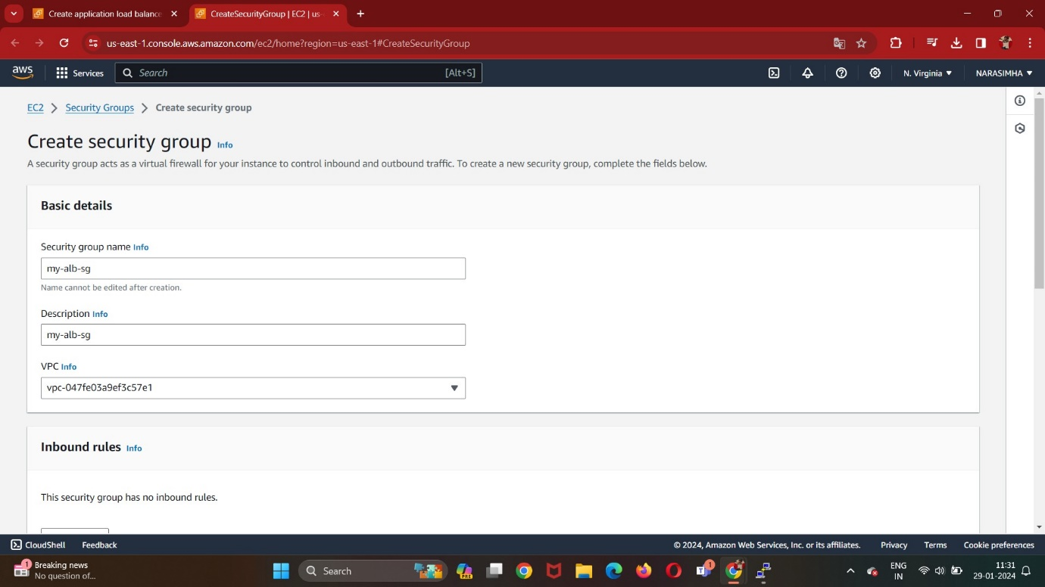

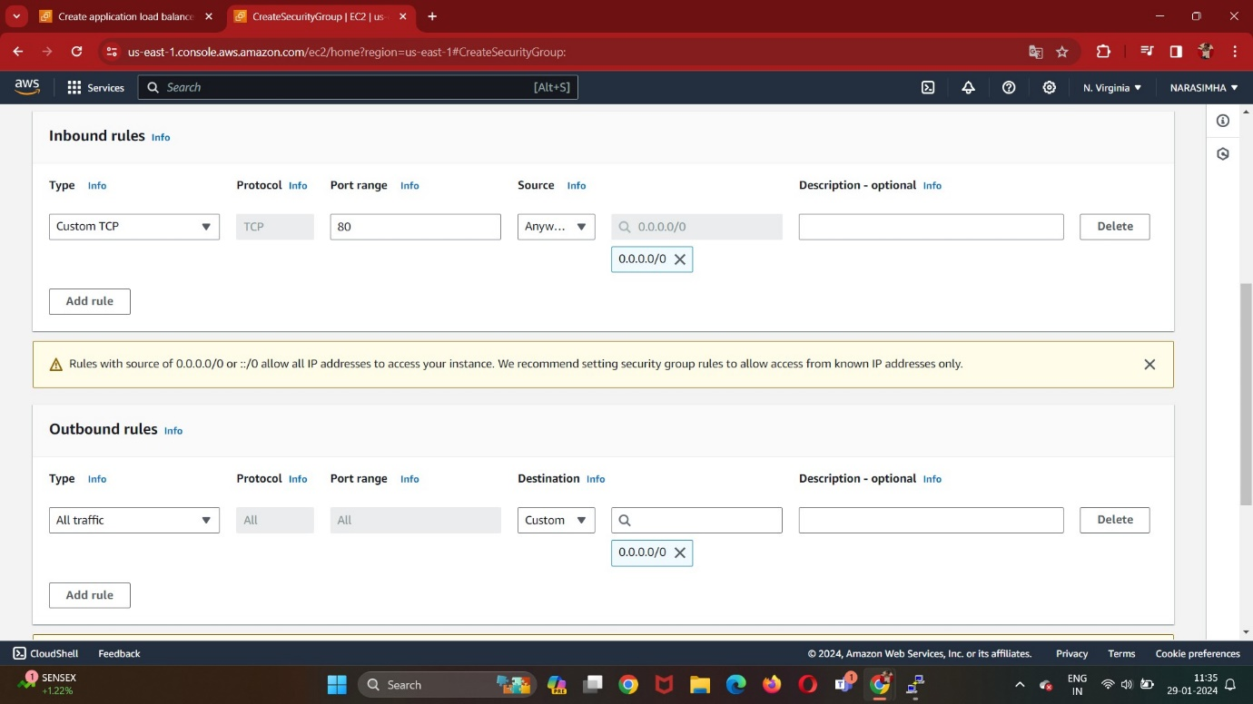

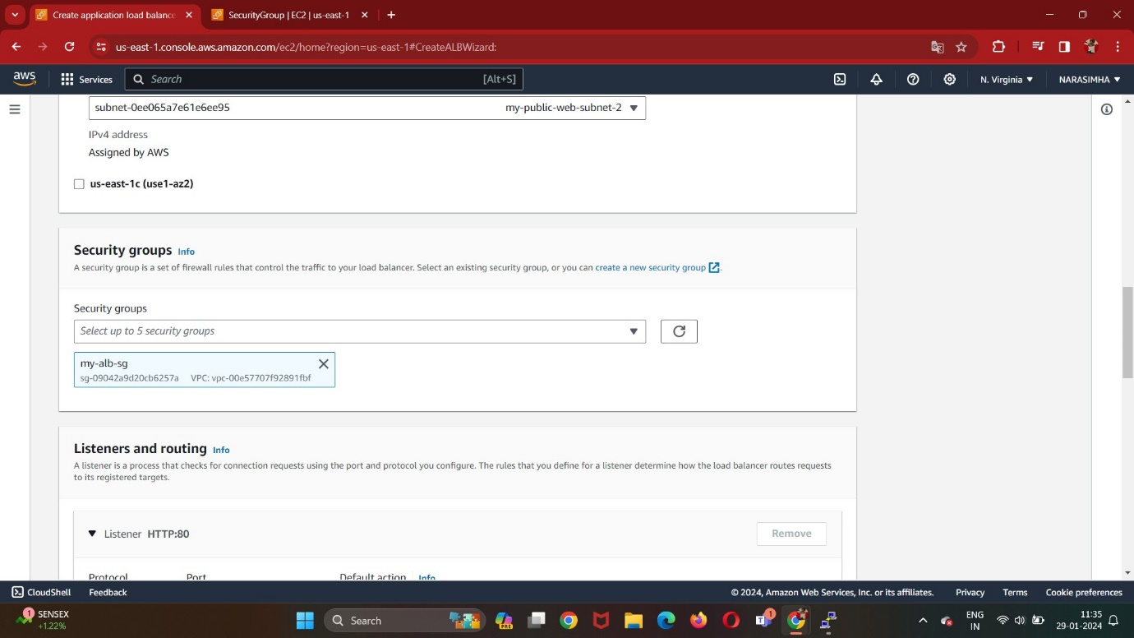

Create Target Groups:

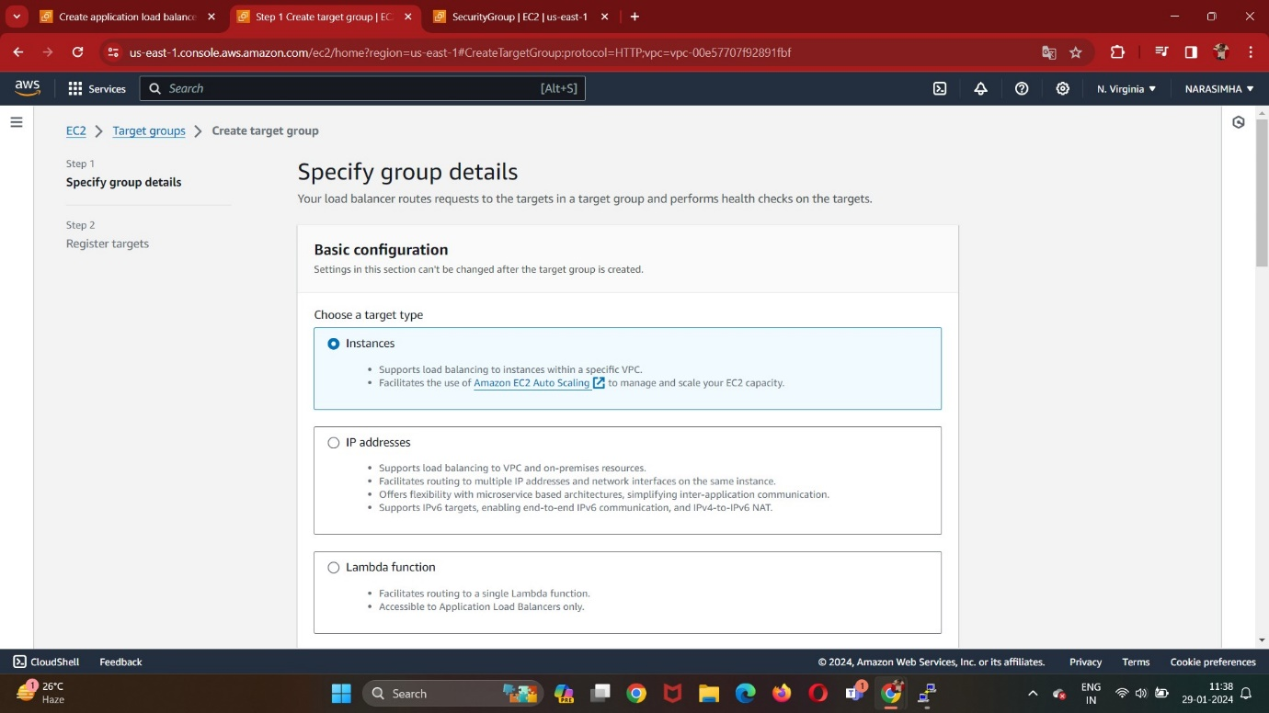

And attach the two php-app instances to the Target Group and then choose the created target group in ALB.

Edit the inbound rules of php-app server-1 Security group:

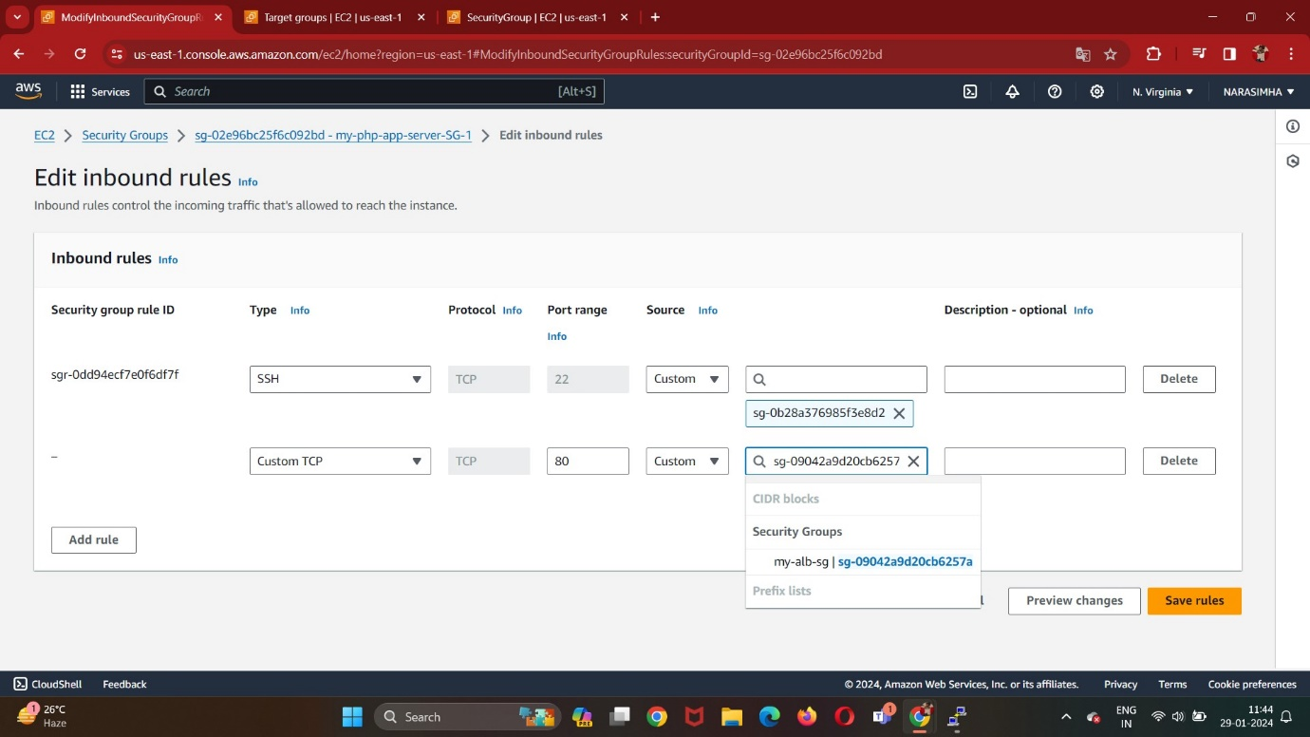

Paste the DNS of ELB om Address Bar:

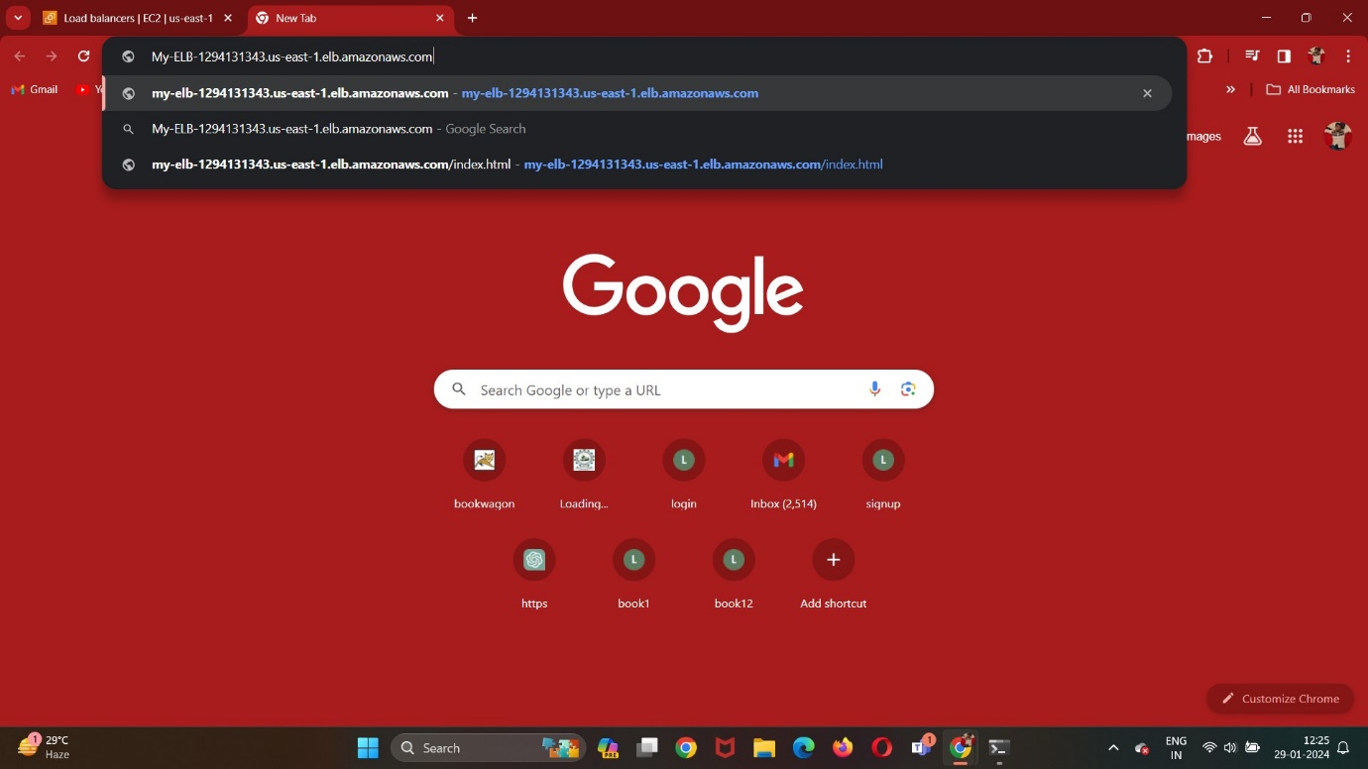

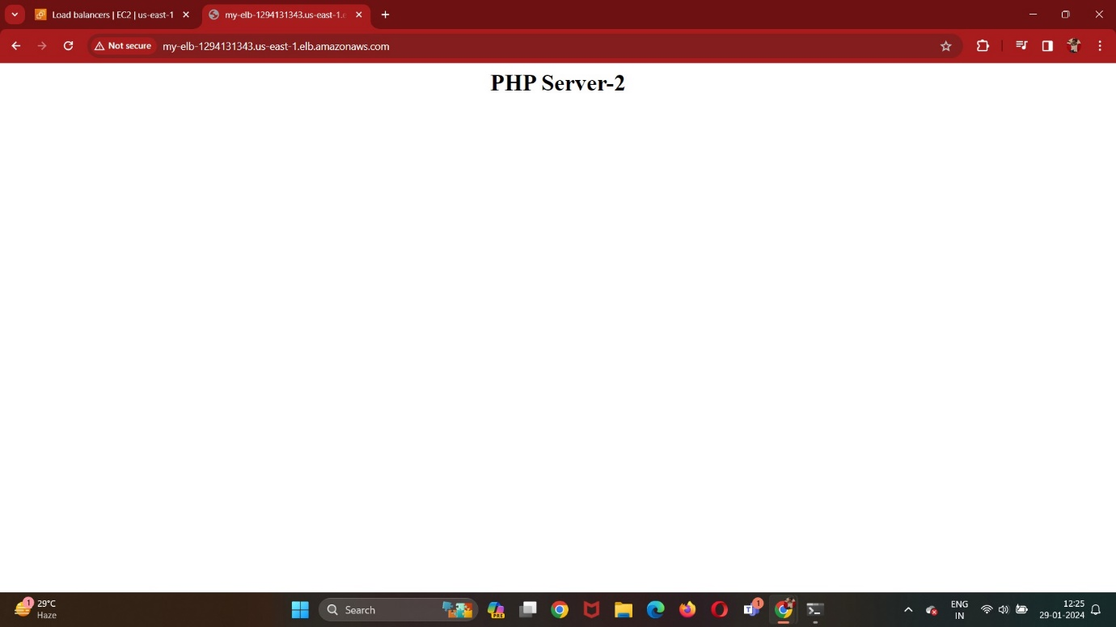

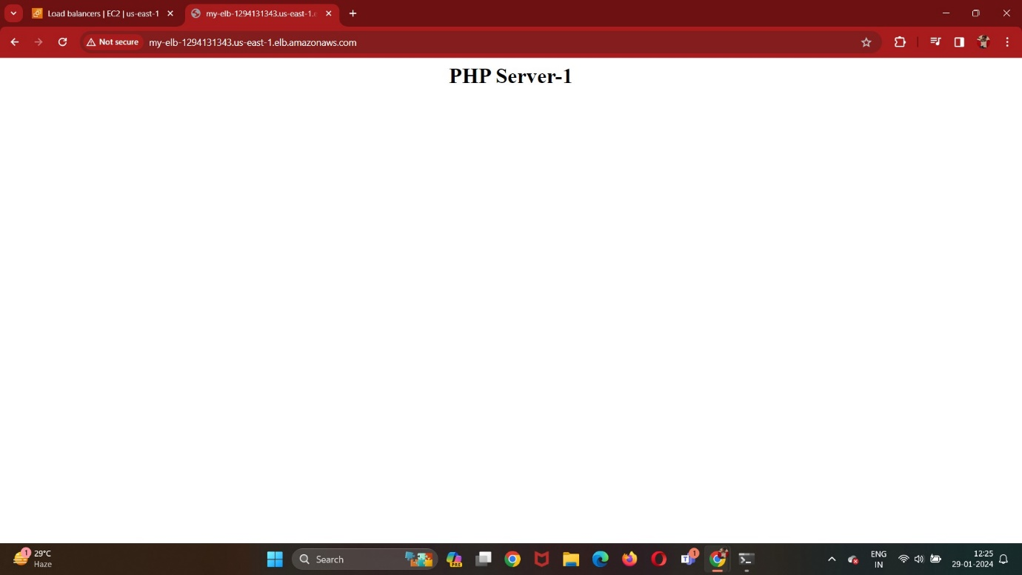

Create DB Subnet Group for RDS:

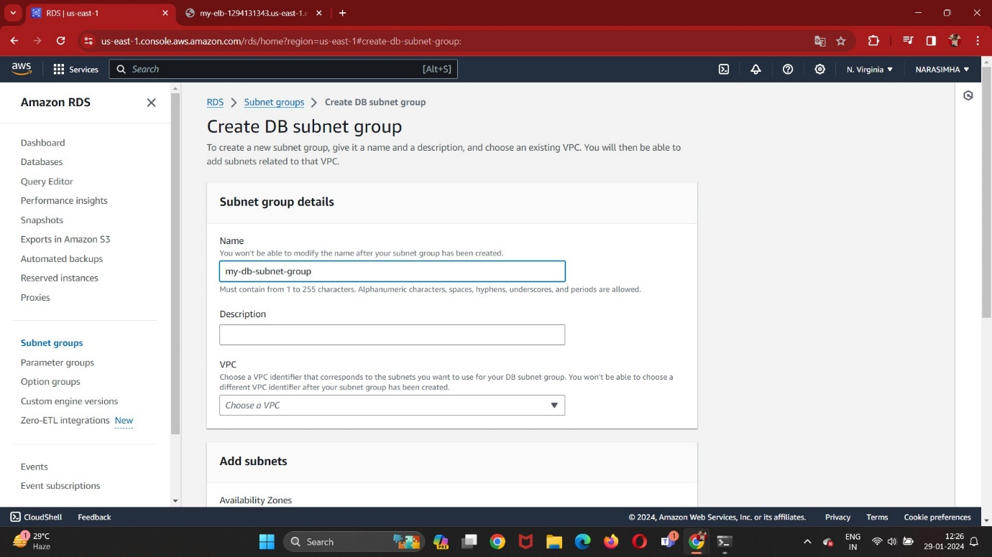

my-public-web-subnet-1 and 2:

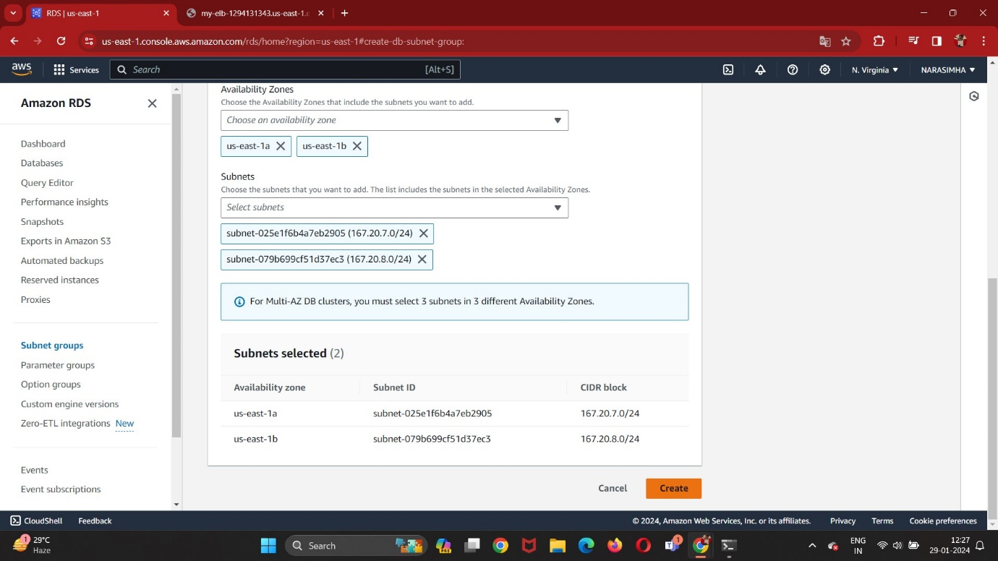

Create Database:

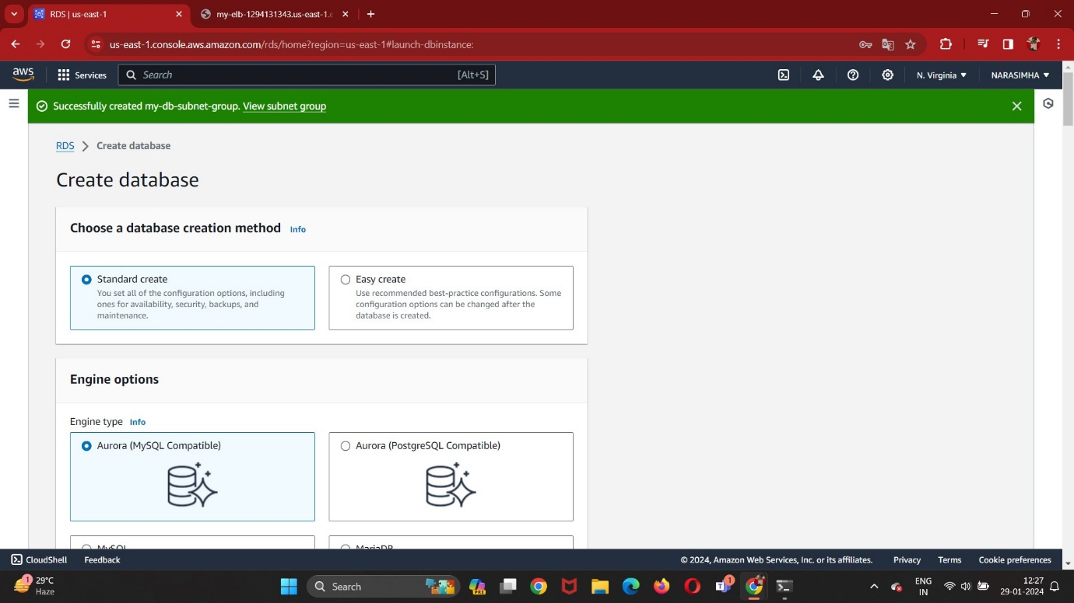

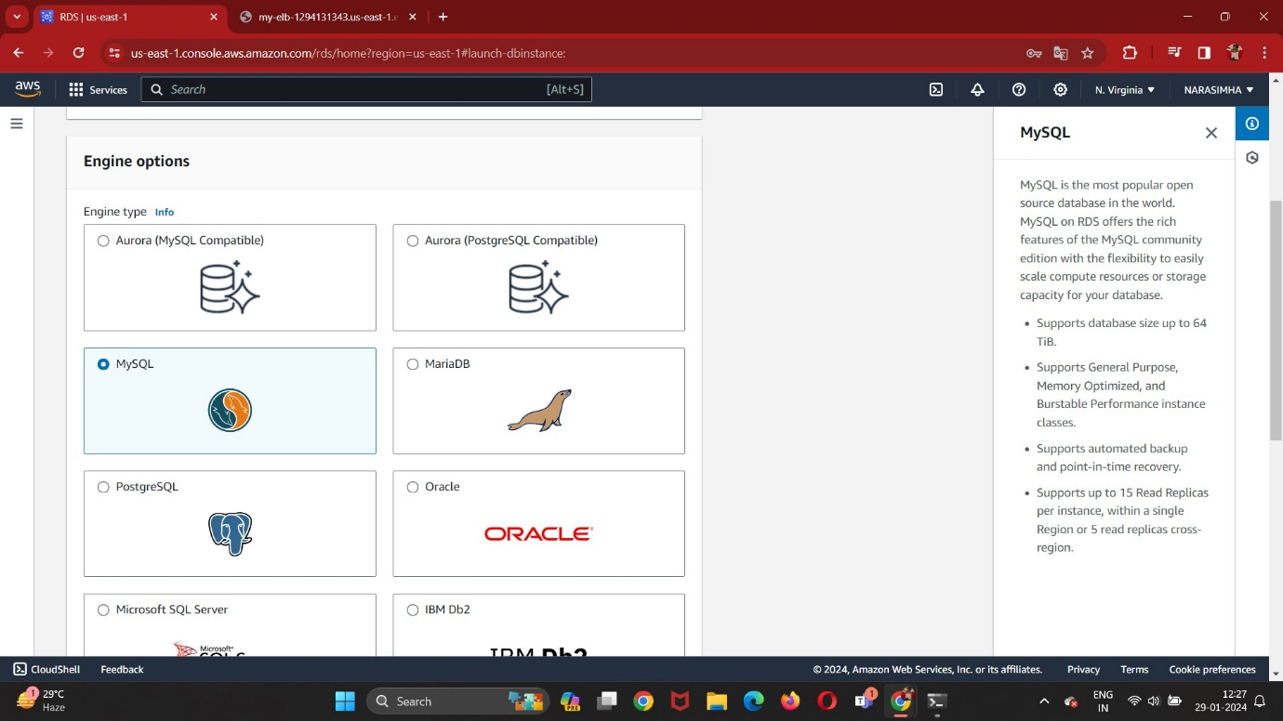

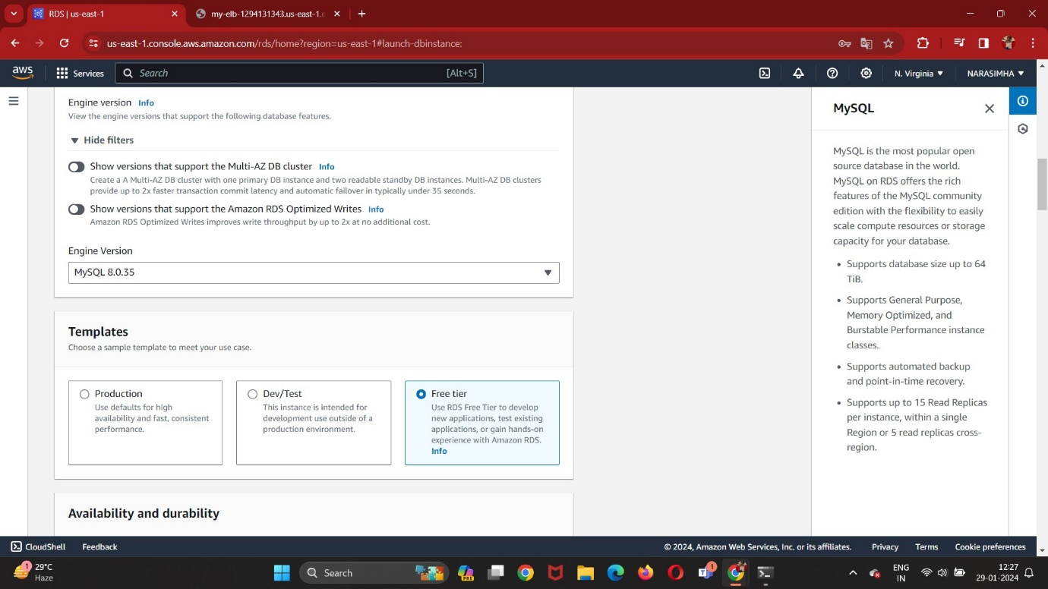

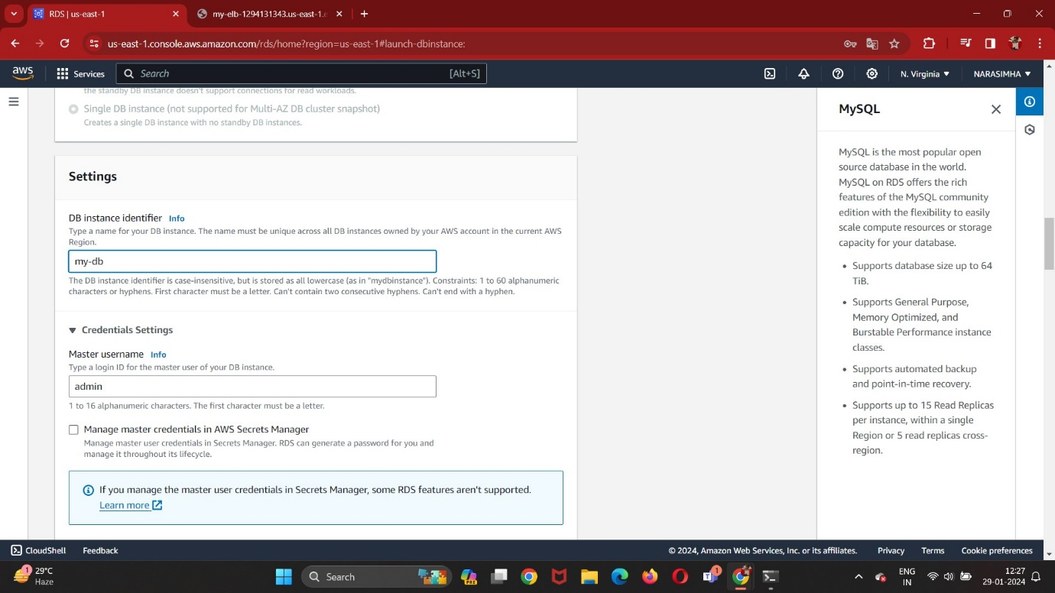

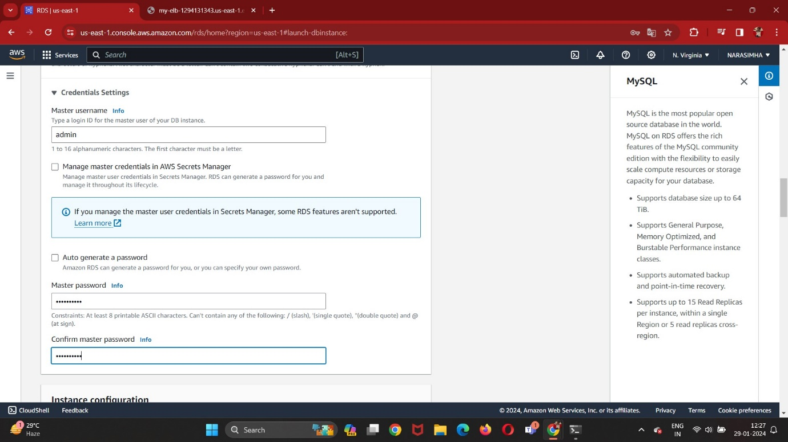

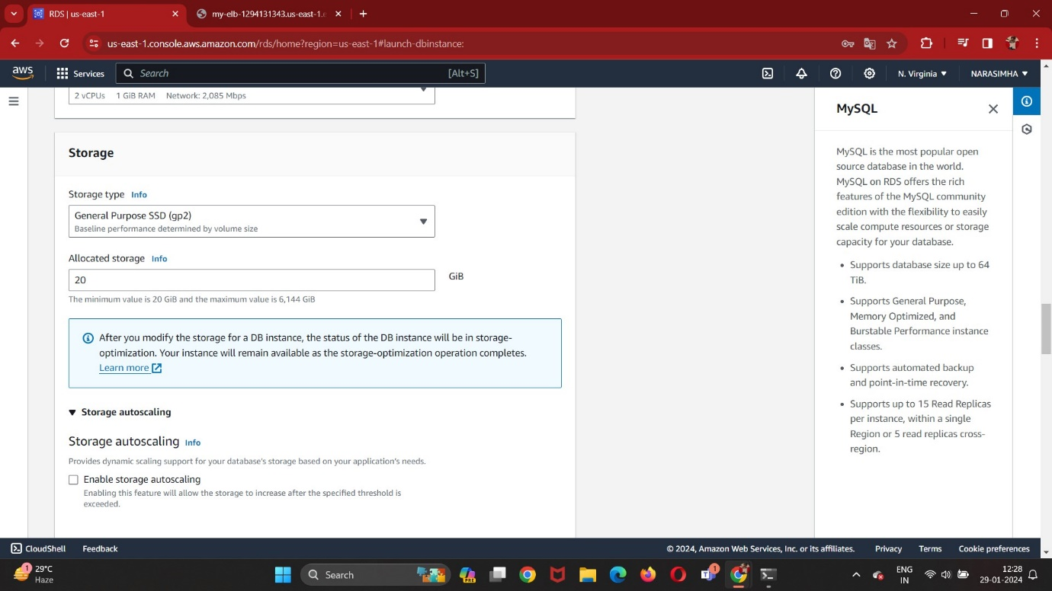

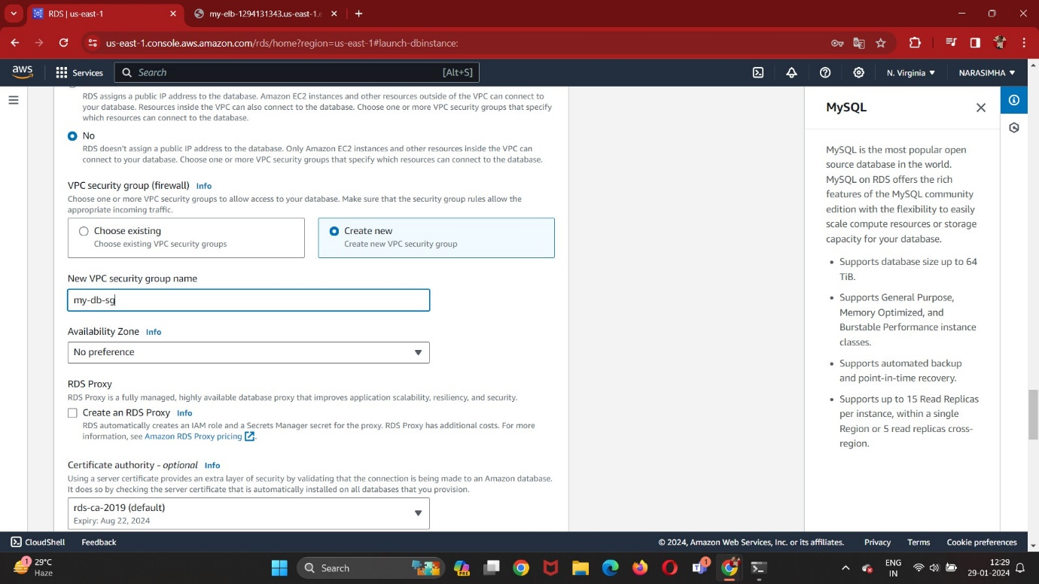

Create a S3 Bucket for Database Backup:

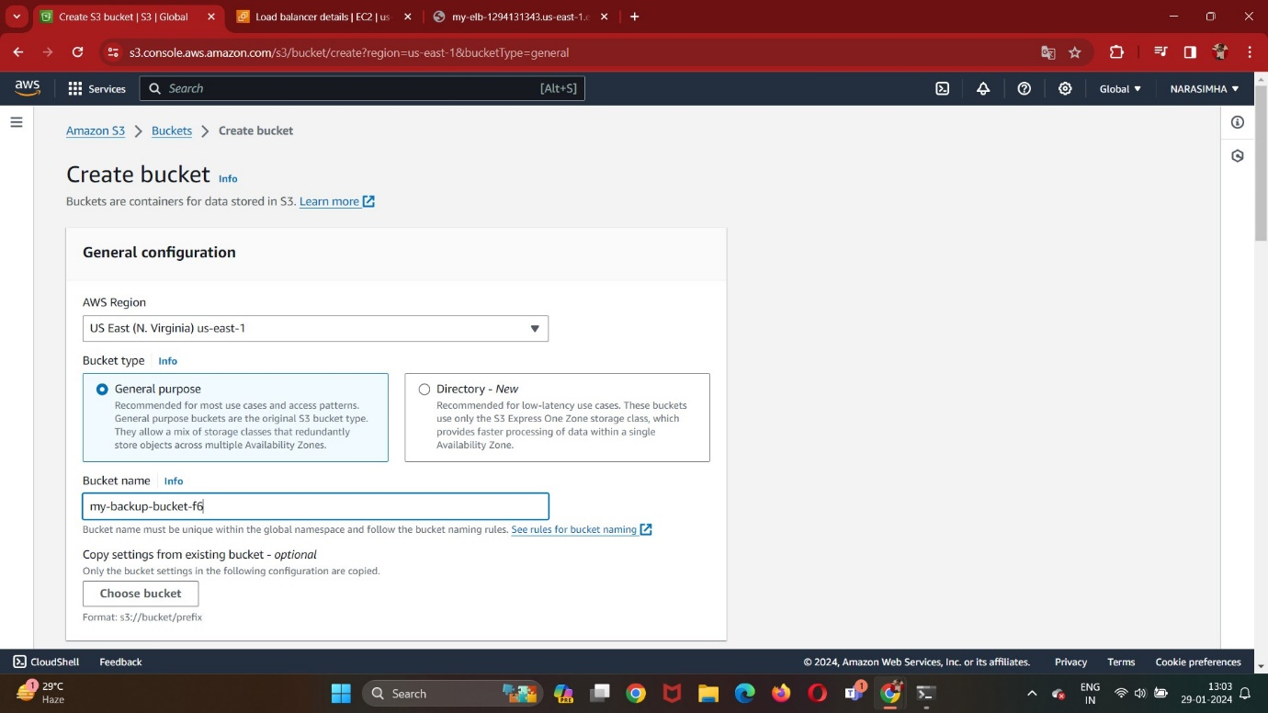

**\**

Create Option Group:

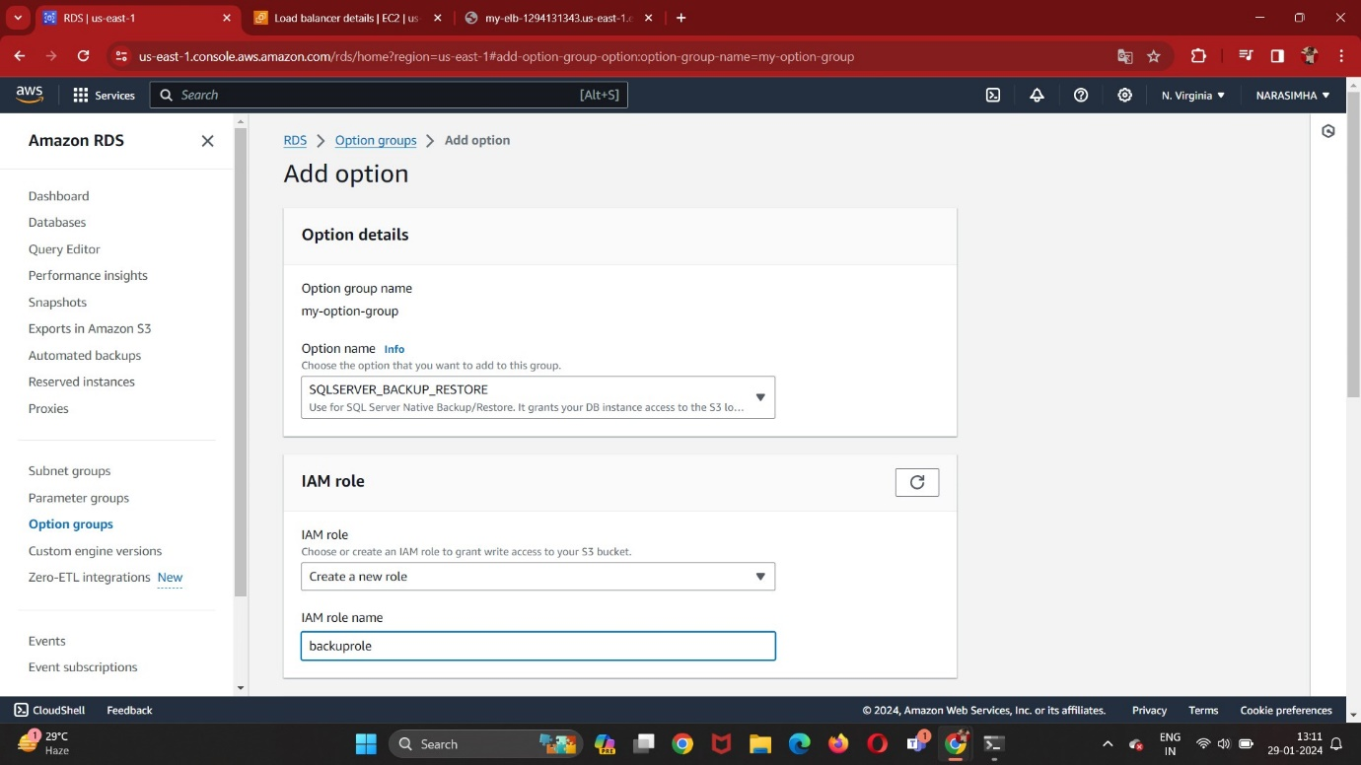

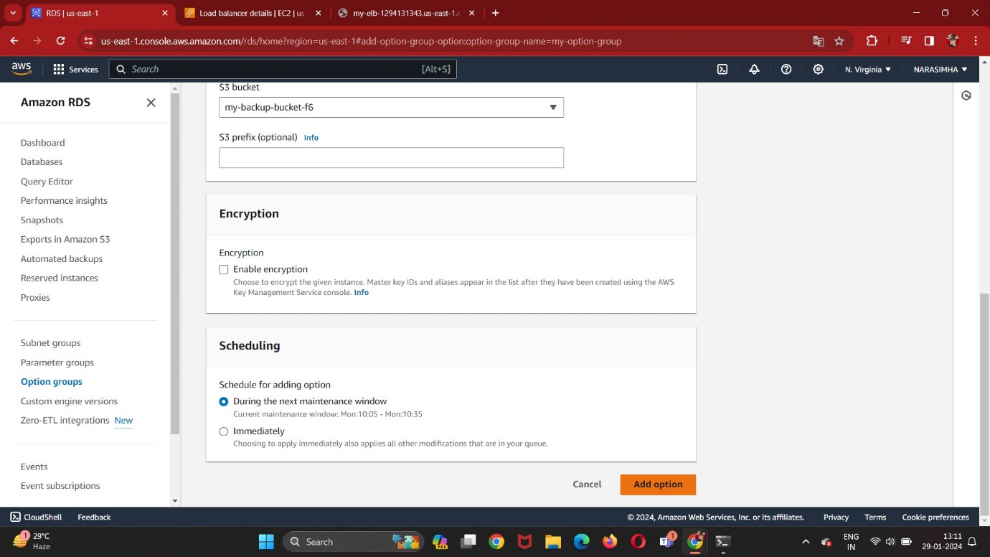

Go to the php-app server-1 instance using ssh-i command with the help of jump server:

Change the directory:

cd phpMyAdmin

and move content:

mv config.sample.inc.php config.inc.php

edit the config.inc.php:

vi config.inc.php

replace “localhost” with End point of Database.

Go to the php-app server-2 instance using ssh-i command with the help of jump server:

Change the directory:

cd phpMyAdmin

and move content:

mv config.sample.inc.php config.inc.php

edit the config.inc.php:

vi config.inc.php

replace “localhost” with End point of Database.

Now copy the ELB DNS URL and paste in the Address Bar with /phpMyAdmin:

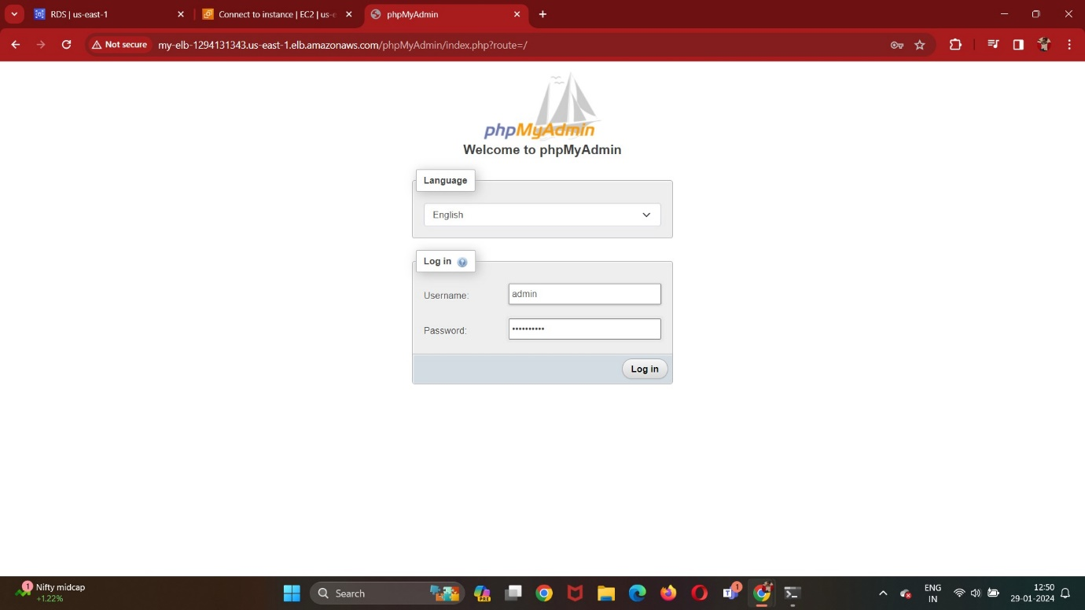

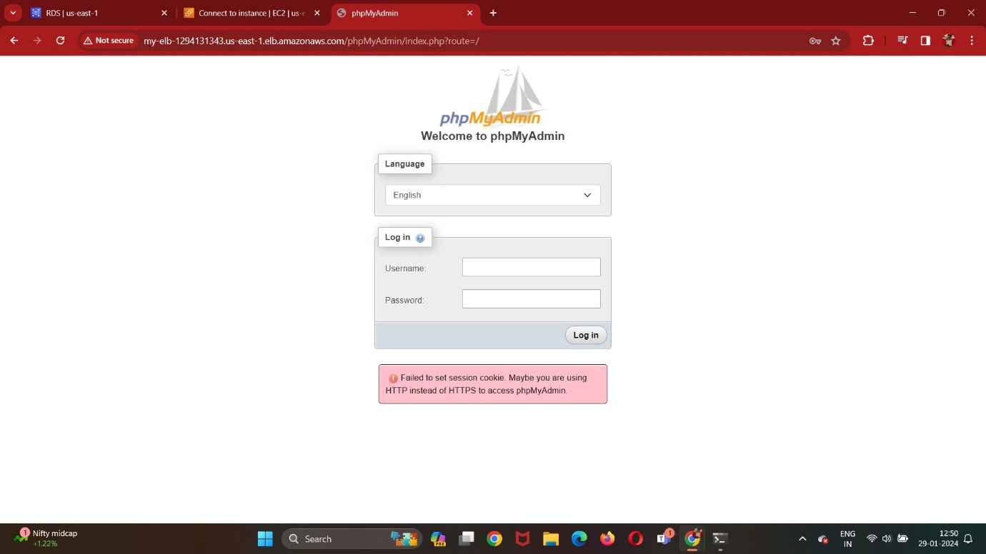

To fix the issue, go to the target groups, under the Attributes tab click on edit and Turn on the “Turn on stickiness”:

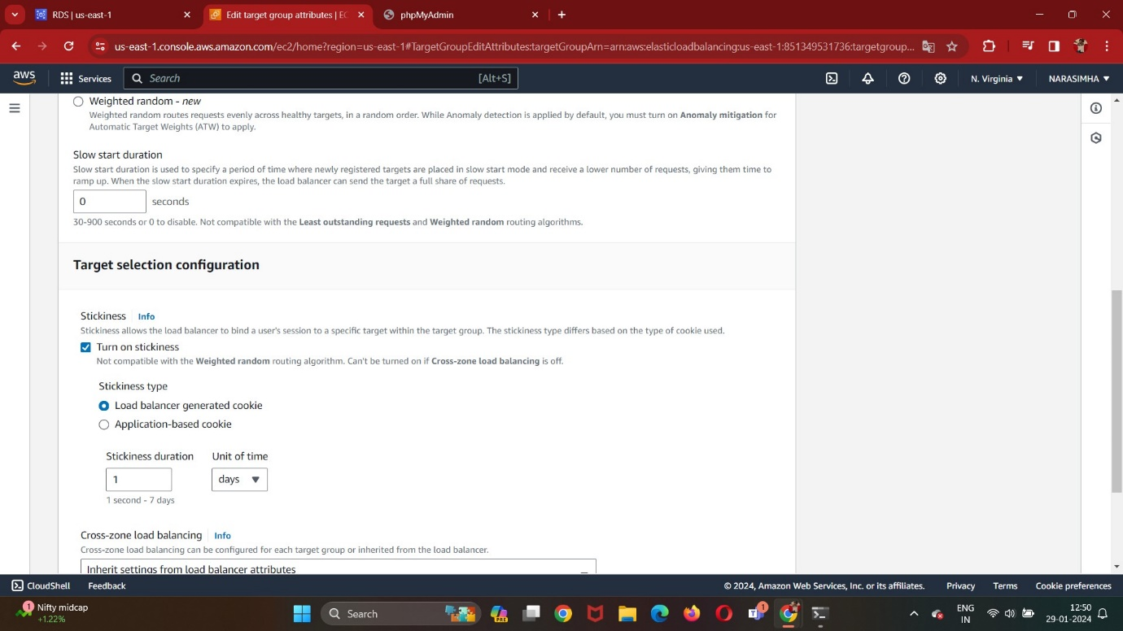

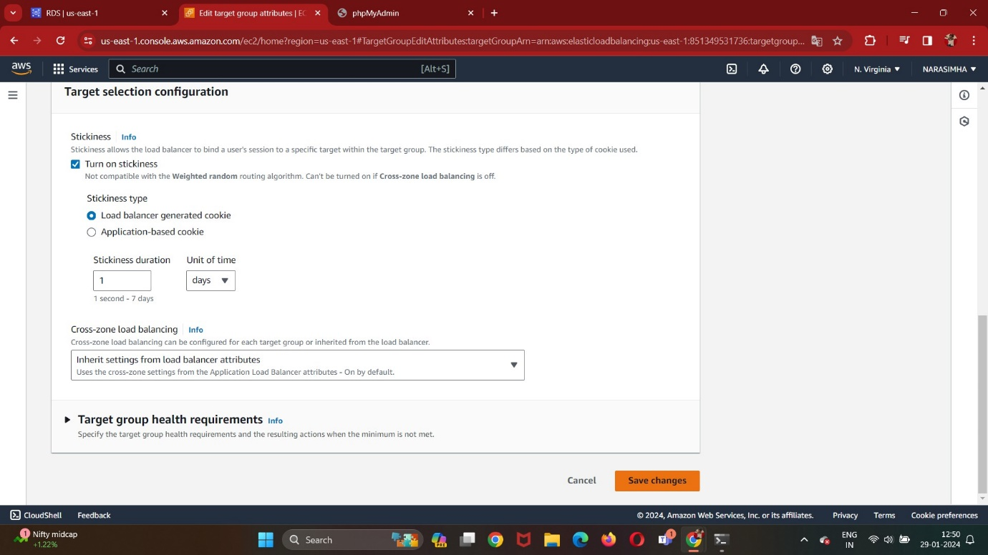

Login the url and perform the database operations:

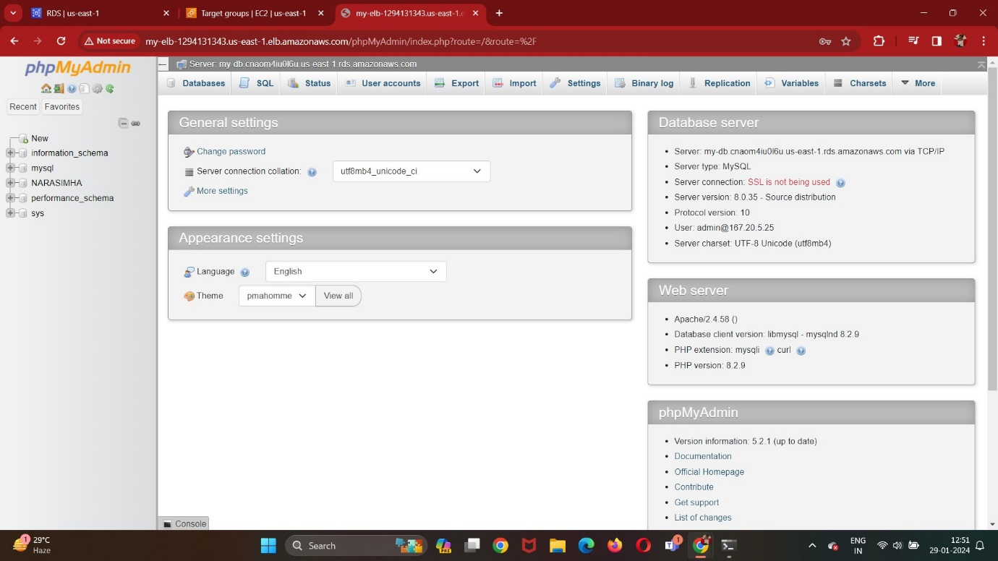

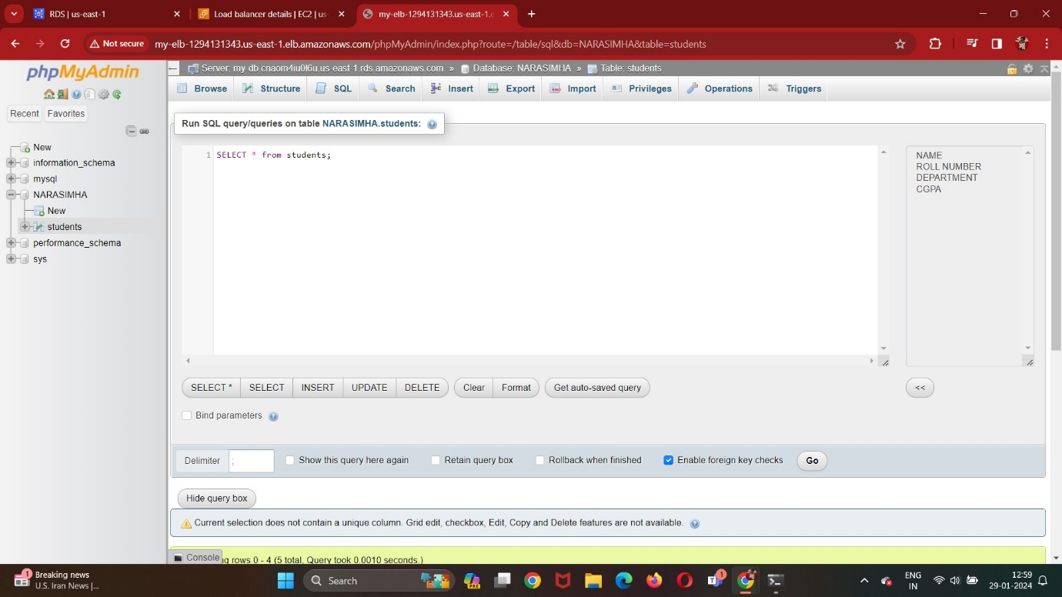

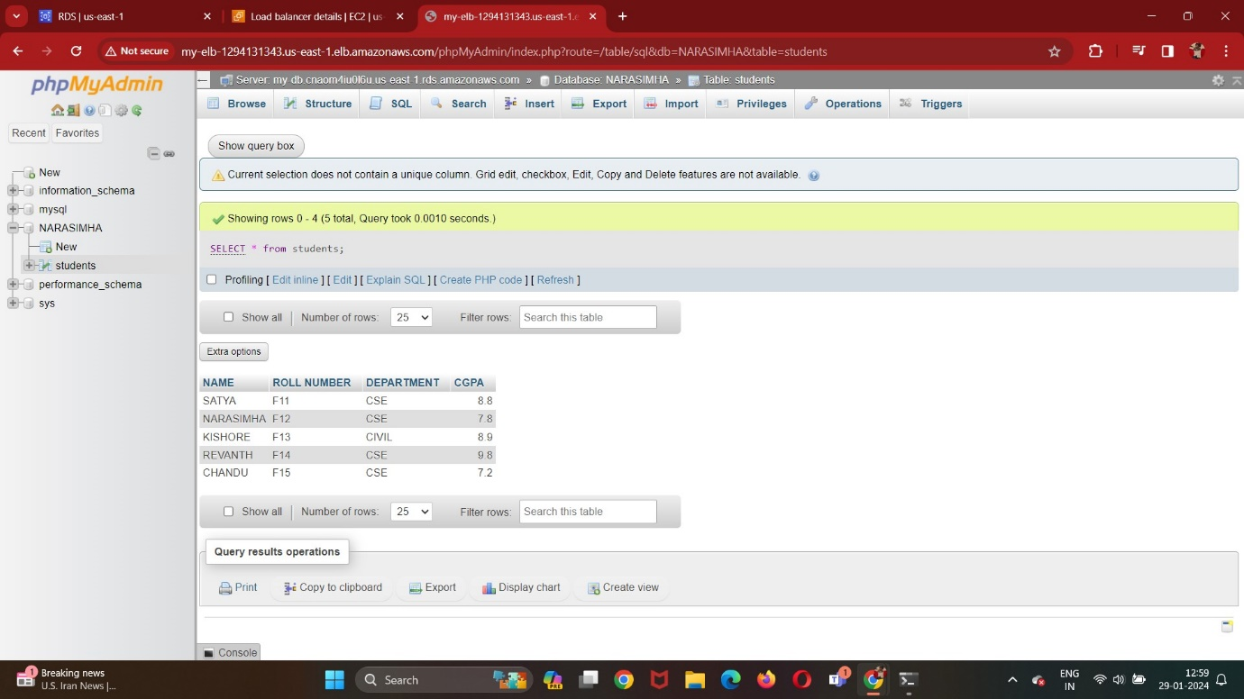

Resource Map For VPC:

